

GUIDELINES FOR THE IMPLEMENTATION OF THE H/V SPECTRAL RATIO TECHNIQUE ON AMBIENT VIBRATIONS
MEASUREMENTS, PROCESSING AND INTERPRETATION

SESAME European research project

WP12 – Deliverable D23.12

European Commission – Research General Directorate
Project No. EVG1-CT-2000-00026 SESAME

December 2004

SESAME: Site EffectS assessment using AMbient Excitations

European Commission, contract n° EVG1-CT-2000-00026

Co-ordinator: Pierre-Yves BARD
Administrative / Accounting assistance: Laurence BOURJOT
Project duration: 1st May 2001 to 31st October 2004
Project Web-site: http://sesame-fp5.obs.ujf-grenoble.fr/index.htm

Participating organisations:
Central Laboratory for Bridges and Roads – Paris, France
Centre of Technical Studies – Nice, France
Geophysical Institute Slovak Academy of Sciences – Bratislava, Slovakia
Institute of Earth and Space Sciences – Lisbon, Portugal
Institute of Engineering Seismology and Earthquake Engineering – Thessaloniki, Greece
National Centre for Scientific Research – Grenoble, France
National Institute of Geophysics and Volcanology – Roma, Italy
National Research Council – Milano, Italy
Polytechnic School of Zürich, Switzerland
Résonance Ingénieurs-Conseils SA – Geneva, Switzerland
University Joseph Fourier – Grenoble, France
University of Bergen, Norway
University of Liège, Belgium
University of Potsdam, Germany

List of participants:

Catello Acerra
Gerardo Aguacil
Anastasios Anastasiadis
Kuvvet Atakan
Riccardo Azzara
Pierre-Yves Bard
Roberto Basili
Etienne Bertrand
Bruno Bettig
Fabien Blarel
Sylvette Bonnefoy-Claudet
Paola Bordoni
Antonio Borges
Mathilde Bøttger Sørensen
Laurence Bourjot
Héloïse Cadet
Fabrizio Cara
Arrigo Caserta
Jean-Luc Chatelain
Cécile Cornou
Fabrice Cotton
Giovanna Cultrera
Rosastella Daminelli
Petros Dimitriu
François Dunand
Anne-Marie Duval
Donat Fäh
Lucia Fojtikova
Roberto de Franco
Giuseppe di Giulio
Margaret Grandison
Philippe Guéguen
Bertrand Guillier
Ebrahim Haghshenas
Hans Havenith
Jens Havskov
Denis Jongmans
Fortunat Kind
Jörg Kirsch
Andreas Koehler
Martin Koller
Josef Kristek
Miriam Kristekova
Corinne Lacave
Alberto Marcellini
Rosalba Maresca
Bassilios Margaris
Fabrizio Marra
Peter Moczo
Bladimir Moreno
Antonio Morrone
Jérôme Noir
Matthias Ohrnberger
Jose Asheim Ojeda
Ivo Oprsal
Marco Pagani
Areti Panou
Catarina Paz
Etor Querendez
Sandro Rao
Julien Rey
Gudrun Richter
Johannes Rippberger
Mario la Rocca
Pedro Roquette
Daniel Roten
Antonio Rovelli
Gilberto Saccoroti
Alekos Savvaidis
Frank Scherbaum
Estelle Schissele
Eva Spühler-Lanz
Alberto Tento
Paula Teves-Costa
Nikos Theodulidis
Eirik Tvedt
Terje Utheim
Jean-François Vassiliades
Sylvain Vidal
Gisela Viegas
Daniel Vollmer
Marc Wathelet
Jochen Woessner
Katharina Wolff
Stratos Zacharopoulos

FOREWORD

Site effects associated with local geological conditions constitute an important part of any seismic hazard assessment. Many examples of catastrophic consequences of earthquakes have demonstrated the importance of reliable analyses procedures and techniques in earthquake hazard assessment and in earthquake risk mitigation strategies. Ambient vibration recordings combined with the H/V spectral ratio technique have been proposed to help in characterising local site effects. This document presents practical user guidelines and software for the implementation of the H/V spectral ratio technique on ambient vibrations.

The H/V spectral ratio method is an experimental technique to evaluate some characteristics of soft-sedimentary (soil) deposits. Due to its low-cost both for the survey and analysis, the H/V technique has been frequently adopted in seismic microzonation investigations. However, it should be pointed out that the H/V technique alone is not sufficient to characterise the complexity of site effects and in particular the absolute values of seismic amplification. The method has proven to be useful to estimate the fundamental period of soil deposits. However, measurements and the analysis should be performed with caution. The main recommended application of the H/V technique in microzonation studies is to map the fundamental period of the site and help constrain the geological and geotechnical models used for numerical computations. In addition, this technique is also useful in calibrating site response studies at specific locations.

These practical guidelines recommend procedures for field experiment design, data processing and interpretation of the results for the implementation of the H/V spectral ratio technique using ambient vibrations. The recommendations given here are the result of a consensus reached by the participants of the European research project SESAME (Contract. No. EVG1-CT-2000-00026), and are based on comprehensive and detailed research work conducted during three years.

It is highly recommended that prior to planning a measurement campaign on ambient vibrations, a local geological survey, especially on Quaternary deposits, should be performed. Interpretation of the H/V results will be greatly enhanced when combined with geological, geophysical and geotechnical information.

In spite of its limitations, the H/V technique is a very useful tool for microzonation and site response studies. This technique is most effective in estimating the natural frequency of soft soil sites when there is a large impedance contrast with the underlying bedrock. The method is especially recommended in areas of low and moderate seismicity, due to the lack of significant earthquake recordings, as compared to high seismicity areas.

TABLE OF CONTENTS

INTRODUCTION 5

PART I: QUICK FIELD REFERENCE AND INTERPRETATION GUIDELINES 7
1. EXPERIMENTAL CONDITIONS + MEASUREMENT FIELD SHEET 8
2. DIAGRAMS FOR INTERPRETATION OF H/V RESULTS 10
2.1 Criteria for reliability of results 10
2.2 Main peak types 10

PART II: DETAILED TECHNICAL GUIDELINES1. TECHNICAL REQUIREMENTS 15
1. TECHNICAL REQUIREMENTS 16
1.1 Instrumentation 16
1.2 Experimental conditions 17
2. DATA PROCESSING STANDARD: J-SESAME SOFTWARE 22
2.1 General design of the software 22
2.2 Window Selection Module 22
2.3 Computing H/V spectral ratio 25
2.4 Showing output results 25
2.5 Setting graph properties and creating images of the output results 26
3. INTERPRETATION OF RESULTS 28
3.1 Underlying assumptions 28
3.2 Conditions for reliability 30
3.3 Identification of f₀ 31
3.3.1 Clear peak 31
3.3.2 "Unclear" cases 32
3.4 Interpretation of f₀ in terms of site characteristics 35
ACKNOWLEDGEMENTS 36
REFERENCES 37
Appendix A: H/V Data Examples 40
A.1 Illustration of the main peak types 40
A.2 Comparison with standard spectral ratios 48
APPENDIX B: Physical explanations 54
B.1 Nature of ambient vibration wavefield 54
B.2 Links between wave type and H/V ratio 56
B.3 Consequences for the interpretation of H/V curves 59

INTRODUCTION

A significant part of damage observed in destructive earthquakes around the world is associated with seismic wave amplification due to local site effects. Site response analysis is therefore a fundamental part of assessing seismic hazard in earthquake prone areas. A number of experiments are required to evaluate local site effects. Among the empirical methods the H/V spectral ratios on ambient vibrations is probably one of the most common approaches. The method, also called the „Nakamura technique“ (Nakamura, 1989), was first introduced by Nogoshi and Igarashi (1971) based on the initial studies of Kanai and Tanaka (1961). Since then, many investigators in different parts of the world have conducted a large number of applications.

An important requirement for the implementation of the H/V method is a good knowledge of engineering seismology combined with background information on local geological conditions supported by geophysical and geotechnical data. The method is typically applied in microzonation studies and in the investigation of the local response of specific sites. In the present document, the application of the H/V technique in assessing local site effects due to dynamic earthquake excitations, is the main focus, whereas other applications regarding the static aspects are not considered.

In the framework of the European research project SESAME (Site Effects Assessment Using Ambient Excitations: Contract No. EVG1-CT-2000-00026), the use of ambient vibrations in understanding local site effects has been studied in detail. The present guidelines on the H/V spectral ratio technique are the result of comprehensive and detailed analyses performed by the SESAME participants during the last three years. In this respect, the guidelines represent the state-of-the-art of the present knowledge of this method and its applications, and are based on the consensus reached by a large group of participants. It reflects the synthesis of a considerable amount of data collection and subsequent analysis and interpretations.

In general, due to the experimental character of the H/V method, the absolute values obtained for a given site require careful examination. In this respect visual inspection of the data both during data collection and processing is necessary. Especially during the interpretation of the results there should be frequent interaction with regard to the choices of the parameters for processing.

The guidelines presented here outline the recommendations that should be taken into account in studies of local site effects using the H/V technique on ambient vibrations. The recommendations given apply basically for the case where the method is used alone in assessing the natural frequency of sites of interest and are therefore based on a rather strict set of criteria. The recommended use of the H/V method is however, to combine several other geophysical and geotechnical approaches with sufficient understanding of the local geological conditions. In such a case, the interpretation of the H/V results can be improved significantly in the light of the complementary data.

The guidelines are organised in two separate parts; the quick field reference and interpretation guidelines (Part I) and detailed technical guidelines (Part II). Part I aims to summarise the most critical factors that influence the data collection, analysis and interpretation and provides schematic recommendations on the interpretation of results. Part II includes a detailed description of the technical requirements, standard data processing and the interpretation of results. Several examples of the criteria described in Part I and II are given in Appendix A. In addition, some physical explanations of the results based on theoretical considerations are given in Appendix B. In Part II, section 1, the results of the experiments performed within the framework of the SESAME project are given in smaller fonts to separate these from the recommendations and the explanations given in the guidelines. The word „soil“ should be considered as a generic term used throughout the text to refer to all kinds of deposits overlying bedrock without taking into account their specific origin.

The processing software J-SESAME developed specifically for using in H/V technique, is explained (provided on a separate CD accompanying the guidelines) in Part II. However, the recommendations given in the guidelines are meant for general application of the method with any other similar software. J-SESAME is provided as a tool for the easy implementation of the recommendations outlined in this document. Regarding the processing of the data, several options can be chosen, but the recommended processing options are provided as defaults by the J-SESAME software.

PART I: QUICK FIELD REFERENCE AND INTERPRETATION GUIDELINES

1. EXPERIMENTAL CONDITIONS + MEASUREMENT FIELD SHEET

→ This sheet is only a quick field reference. It is highly recommended that the complete guidelines be read before going out to perform the recordings. A field sheet is also provided on the next page. This page, containing two identical sheets can be printed and be taken in the field.

Type of parameter | Main recommendations
Recording duration | Minimum expected f₀ [Hz] | Recommended minimum recording duration [min]
Recording duration | 0.2 | 30'
Recording duration | 0.5 | 20'
Recording duration | 1 | 10'
Recording duration | 2 | 5'
Recording duration | 5 | 3'
Recording duration | 10 | 2'
Measurement spacing | → Microzonation: start with a large spacing (for example a 500 m grid) and, in case of lateral variation of the results, densify the grid point spacing, down to 250 m, for example.  → Single site response: never use a single measurement point to derive an f₀ value, make at least three measurement points.
Recording parameters | → level the sensor as recommended by the manufacturer.  → fix the gain level at the maximum possible without signal saturation.
In situ soil-sensor coupling | → set the sensor down directly on the ground, whenever possible.  → avoid setting the sensor on "soft grounds" (mud, ploughed soil, tall grass, etc.), or soil saturated after rain.
Artificial soil-sensor coupling | → avoid plates from "soft" materials such as foam rubber, cardboard, etc.  → on steep slopes that do not allow correct sensor levelling, install the sensor in a sand pile or in a container filled with sand.  → on snow or ice, install a metallic or wooden plate or a container filled with sand to avoid sensor tilting due to local melting.
Nearby structures | → Avoid recording near structures such as buildings, trees, etc. in case of wind blowing (faster than approx. 5 m/s). It may strongly influence H/V results by introducing some low frequencies in the curves  → Avoid measuring above underground structures such as car parks, pipes, sewer lids, etc.
Weather conditions | → Wind: Protect the sensor from the wind (faster than approx. 5 m/s). This only helps if there are no nearby structures.  → Rain: avoid measurements under heavy rain. Slight rain has no noticeable influence.  → Temperature: check sensor and recorder manufacturer's instructions.  → Meteorological perturbations: indicate on the field sheet whether the measurements are performed during a low-pressure meteorological event.
Disturbances | → Monochromatic sources: avoid measurements near construction machines, industrial machines, pumps, generators, etc.  → Transients: In case of transients (steps, cars,...), increase the recording duration to allow for enough windows for the analysis, after transient removal.

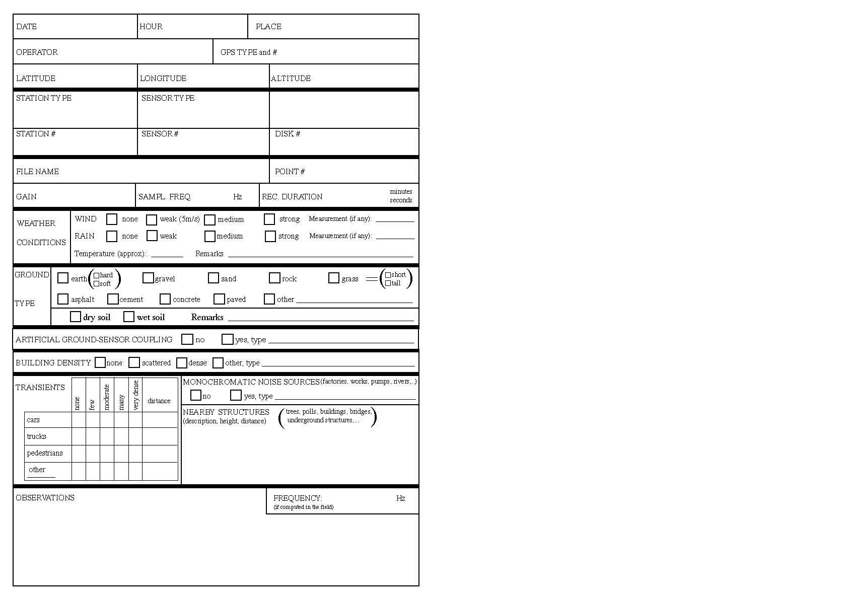

DIAGRAMS FOR INTERPRETATION OF H/V RESULTS

This section presents diagrams with criteria and recommendations to help in the result interpretation for different cases. For detailed explanations of each case, see section 3 in Part II of the guidelines. See Appendix A for illustrations. The definitions given in the table below are valid for all section 2.

2.1 Criteria for reliability of results

Criteria for a clear H/V peak
(at least 5 out of 6 criteria fulfilled)
i)∃ f⁻ ∈ [f₀/4, f₀] | A_{H/V}(f⁻) < A₀/2
ii)∃ f⁺ ∈ [f₀, 4f₀] | A_{H/V}(f⁺) < A₀/2
iii)A₀ > 2
iv)f_{peak}[A_{H/V}(f) ± σ_{A}(f)] = f₀ ±5%
v)σ_{f} < ε(f₀)
vi)σ_{A}(f₀) < θ (f₀)
l_{w} = window length
n_{w} = number of windows selected for the average H/V curve
n_{c} = l_{w} . n_{w}. f₀ = number of significant cycles
f = current frequency
f_{sensor} = sensor cut-off frequency
f₀ = H/V peak frequency
σ_{f} = standard deviation of H/V peak frequency (f₀ ± σ_{f})
ε (f₀) = threshold value for the stability condition σ_{f} < ε(f₀)
A₀ = H/V peak amplitude at frequency f₀
A_{H/V} (f) = H/V curve amplitude at frequency f
f⁻ = frequency between f₀/4 and f₀ for which A_{H/V}(f⁻) < A₀/2
f⁺ = frequency between f₀ and 4f₀ for which A_{H/V}(f⁺) < A₀/2
σ_{A} (f) = "standard deviation" of A_{H/V} (f), σ_{A} (f) is the factor by which the mean A_{H/V}(f) curve should be multiplied or divided
σ_{logH/V} (f) = standard deviation of the logA_{H/V}(f) curve, σ_{logH/V} (f) is an absolute value which should be added to or subtracted from the mean logA_{H/V}(f) curve
θ (f₀) = threshold value for the stability condition σ_{A}(f) < θ(f₀)
V_{s,av} = average S-wave velocity of the total deposits
V_{s,surf} = S-wave velocity of the surface layer
h = depth to bedrock
h_{min} = lower-bound estimate of h

Threshold Values for σ_{f} and σ_{A}(f₀)Frequency range [Hz] < 0.20.2 – 0.50.5 – 1.01.0 – 2.0> 2.0ε (f₀) [Hz]0.25 f₀0.20 f₀0.15 f₀0.10 f₀0.05 f₀θ (f₀) for σ_{A} (f₀)3.02.52.01.781.58log θ (f₀) for σ_{logH/V} (f₀)0.480.400.300.250.20
Criteria for a reliable H/V curve
i)f₀ > 10 / l_{w}
and
ii)n_{c} (f₀) > 200
and
σ_{A}(f)<2 for 0.5f₀<f<2f₀ if f0>0.5Hz
orσ_{A}(f)<3 for 0.5f₀<f<2f₀ if f0<0.5Hz

2.2 Main peak types

This section is not an exhaustive list of the different types of H/V curves that might be obtained, but it gives suggestions for the processing and interpretation of the most common situations.

Sharp peaks and industrial originsee $3.3.2.d and appendix A
If industrial origin is proved, i.e., if
raw spectra exhibit sharp peaks on all components
random decrement technique indicates very low damping (< 5%)
peaks get sharper with decreasing smoothing
no reliable f₀
If industrial origin is not obvious
Perform continuous recordings during day and night
Check the existence of 24 h / 7 day plant within the area

Clear peaksee $3.3.1 and appendix A
If industrial origin ( $3.3.2.d ) , i.e.
the raw spectra exhibit sharp peaks on all three components
the random decrement technique indicates very low damping (< 5%)
peaks get sharper with decreasing smoothing
f₀ reliable

Likely sharp contrast at depth (A₀ > 4-5)
f₀ = fundamental frequency
If h is known then V_{S,av} ~ 4h.f₀
If V_{S,surf} is known then h_{min} ~ V_{S,surf}/4f₀
no reliable f₀
If f₀ > f_{sensor} and no industrial origin

Sharp peakssee $3.3.2.d and appendix A
If industrial origin
raw spectra exhibit sharp peaks on all components
random decrement technique indicates very low damping
peaks get sharper with decreasing smoothing
f₀ not reliable
If industrial origin is not obvious
Perform continuous recordings during day and night
Check the existence of 24h/24h plant within the area

Unclear low frequency peaksee $3.3.2.b and appendix A
If rock site
no reliable f₀
If steady increase of H/V ratio with decreasing frequency
Check H/V curves from individual windows and eliminate windows giving spurious H/V curves
Use longer time windows and/or more stringent window selection criteria
Use proportional bandwidth and less smoothing
If reprocessed H/V curve does not fulfil the clarity criteria
If reprocessed H/V curve fulfils the clarity criteria
f₀ reliable
Perform additional measurements over a
longer time and/or during night and/or quiet weather conditions and/or use earthquake recordings using also a nearby rock site
Broad peaksee $3.3.2.c and appendix A
Decrease the smoothing bandwidth
If bump peak is not stable and/or A_{H/V}(f) is very large
If bump peak is stable and
A_{H/V}(f) is rather low
If clearer peaks are observed in the vicinity and
- if their related frequencies lie within the
frequency range of the broad peak
- if their related frequencies exhibit significant
variation from site to site
Then, examine the possibility of underground lateral variation, especially slopes.
Otherwise not recommended to extract any information
no reliable f₀

Multiple peaks (multiplicity of maxima) see $3.3.2.c and Appendix A
Check no industrial origin of one of the peaks
Increase the smoothing bandwidth
If reprocessed H/V curve does not fulfil the clarity criteria
If reprocessed H/V curve fulfils the clarity criteria
f₀ reliable
Redo measurements over a longer time and/or during night

2 peaks cases (f₁ > f₀)see $3.3.2.d and appendix A
If the geology of the site shows possibility of having two large velocity contrasts at two different scales
AND
The clarity criteria are fulfilled for both f0 and f1
f₀ and f₁ reliable

Likely two large contrasts at shallow and large depth at two different scales
f₀ = fundamental frequency
f1 = other natural frequency
If V_{S,surf} is known then h_{1,min} ~ V_{s,surf}/4f₁
If industrial origin of f₀
AND
No industrial origin for f₁
f₀ not reliable and f₁ reliable

Likely sharp contrast at shallow depth
f₁ = fundamental frequency
If h is known then V_{S,av} ~ 4h.f₁
If V_{S,surf} is known then h_{min} ~ V_{S,surf}/4f₁
If industrial origin of f₁
AND
No industrial origin for f₀
f₀ reliable and f₁ not reliable

Likely sharp contrast at rather large depth
f₀ = fundamental frequency
If h is known then V_{S,av} ~ 4h.f_{o}
If V_{S,surf} is known then h_{min} ~ V_{S,surf}/4f_{o}

Flat H/V curve (meeting the reliability conditions)see $3.4 and appendix A
Likely absence of any sharp contrast at depth
Does not necessarily mean no amplification
Perform earthquake recordings on site and nearby rock site
Use of other geophysical techniques
if soil deposits
if rock
likely unweathered or only lightly weathered rock
may be considered as a good reference site

PART II: DETAILED TECHNICAL GUIDELINES

1. TECHNICAL REQUIREMENTS

It is important to understand which recording parameters influence data quality and reliability as this can help speed up the recording process. H/V measurements in cities are conducted within the following context:
- Anthropic noise is very high.
- It is quite rare to be able to get data on the soil per se. Most data will be obtained on streets and sidewalks (i.e. asphalt, pavement, cement or concrete), and to a lesser extent in parks (i.e. on grass or soil).
- Measurements are performed in an environment dominated by buildings of various dimensions.
- Recordings are not always performed at the same time and under the same weather conditions.
- The presence of underground structures (i.e. pipes,...) is often unknown.

The influence of various types of experimental parameter had to be tested on the results of H/V curves both in frequency and amplitude. For each tested parameter, H/V data were compared with a "reference situation". This comparison had to be made in an objective way, i.e. with the use of a statistical method. The Student-t test was chosen as it is one of the most commonly used techniques for testing an hypothesis on the basis of a difference between sample means. It determines a probability that two populations are the same with respect to the variable tested. The t-test can be performed knowing only the means, standard deviation, and number of data points. For further details, or for users who would like to perform some comparison on their own, please refer to the SESAME WP02 Controlled instrumentation specification, Final report. Further investigations would be welcome in some cases using a common software process and processing parameters to compare records and quantify their similarity.

This chapter is based on the following SESAME internal reports:
– WP02 Controlled instrumentation specification, Final report, Deliverable D01.02,
– WP02 H/V technique : experimental conditions, Final report, Deliverable D08.02.

1.1 Instrumentation
An instrument workshop was held during the SESAME project to investigate the influence of different instruments in using the H/V technique with ambient vibration data. There were four major tasks performed, which consisted of testing the digitisers and sensors, and of making simultaneous recordings both outside in the free field and at the lab for comparisons.

Influence of the digitiser
In order to investigate the possible influence of the digitisers, several tests were performed to quantify the experimental sensitivity, internal noise, stability with time and channel consistency. The influence of various parameters was checked (warm up time, electronic noise, synchronism between channels, difference of gain between channels, etc.):
→ Most of the tested digitisers finally gave correct results.
→ In general it was found that all digitisers need some warm up time. From 2 to 10 minutes is usually sufficient for most instruments to assure that the baseline is more or less stable. Users are encouraged to test instrument stability before use.
→ For an optimal analysis of the H/V curve, it appears to be necessary to check the energy density along the studied frequency band, to ensure that the energy is sufficient to allow the extraction of the signal from the instrumental noise. Furthermore, deviations must be the same on all components.
→ Users should check synchronisation between channels: From numerical simulation, it was demonstrated that no H/V modification occurs below 15 Hz. Over 15 Hz modifications in the H/V results depend on the percentage of sample desynchronisation, the minimum being obtained for a round number of desynchronised samples and the maximum (up to 80% of H/V amplitude change) for 0.5 sample.
→ Users should choose the same gain for all three channels. Small gain differences might cause slight changes to the results.

Influence of the sensor
The influence of the type of sensor was tested by recording simultaneously with two sensors coupled to the same digitiser. In total 17 sensors were tested. In general, signals are similar, as expected. However,
→ The accelerometers were not sensitive enough for frequencies lower than 1 Hz and give very unstable H/V results. It is not recommended that H/V measurements be performed using seismology accelerometers, as they are not sensitive enough for ambient vibration levels.
→ Stability is important. It is not recommended that H/V measurements be performed using broadband seismometers (with natural period higher than 20 s), as they require a long stabilisation time, without providing any further advantage. Users are encouraged to test sensor stability before use.
→ It is not recommended that sensors that have their natural frequency above the lowest frequency of interest be used. If f₀ is lower than1 Hz, while the sensor used is a high frequency velocimeter, double check the results with the procedure indicated in 3.3.2.b.

1.2 Experimental conditions
As a general recommendation, it is suggested that before doing H/V measurements on the field, the team should have a look at the available geological information about the study area. In particular, the types of geological formations, the possible depth to the bedrock, and possible 2D or 3D structures should be looked at.

An evaluation of the influence of experimental conditions on the stability and reproducibility of H/V estimations from ambient vibrations was carried out during the SESAME project [2]. The results obtained are based on 593 recordings used to test 60 experimental conditions that can be divided into categories, as following:
– recording parameters,
– recording duration,
– measurement spacing,
– in-situ soil-sensor coupling,
– artificial soil-sensor coupling,
– sensor setting,
– nearby structures,
– weather conditions,
– disturbances.

Recording parameters
→ As long as there is no signal saturation, results are equivalent irrespective of the gain used. However, we suggest fixing the gain level at the maximum possible without signal saturation. The only noticeable effect is a compression of the H/V curve when too high a gain value is used implying too much saturation of the signal.
→ A sampling rate of 50 Hz is sufficient, as the maximum frequency of engineering interest is not higher than 25 Hz, although higher sampling rates do not influence H/V results.
→ Length of cable to connect the sensor to the station does not influence H/V results at least up to a length of 100 meters.

Recording duration
→ In order for a measurement to be reliable, we recommend the following condition to be fulfilled : f₀ > 10 / l_{w}. This condition is proposed so that, at the frequency of interest, there be at least 10 significant cycles in each window (see Table 1).
→ A large number of windows and of cycles is needed: we recommend that the total number of significant cycles : n_{c} = l_{w} . n_{w} .f₀ be larger than 200 (which means, for instance, that for a peak at 1 Hz, there be at least 20 windows of 10 s each; or, for a peak at 0.5 Hz, 10 windows of 40 s each, or 20 windows of 20 s, but not 40 windows of 10 s). See Table 1 for other frequencies of interest.

As there might be some transients during the recording, these should be removed from the signal for processing, and the total recording duration should be increased, in order to have the above mentioned conditions fulfilled for "good quality" signal windows.

Table 1. Recommended recording duration.
f₀ [Hz] | Minimum value for l_{w} [s] | Minimum number of significant cycles (n_{c}) | Minimum number of windows | Minimum useful signal duration [s] | Recommended minimum record duration [min]
0.2 | 50 | 200 | 10 | 1000 | 30'
0.5 | 20 | 200 | 10 | 400 | 20'
1 | 10 | 200 | 10 | 200 | 10'
2 | 5 | 200 | 10 | 100 | 5'
5 | 5 | 200 | 10 | 40 | 3'
10 | 5 | 200 | 10 | 20 | 2'

Measurement spacing
→ For a microzonation, it is recommended that a large spacing be initially adopted (for example a 500 m grid) and, in case of lateral variation of the results, to densify the grid point spacing, down to 250 m, for example.
→ For a single site response study, one should never use a single measurement point to derive an f₀ value. It is recommended that at least three measurement points be used.

In situ soil-sensor coupling
In situ soil / sensor coupling should be handled with care. Concrete and asphalt provide good results, whereas measuring on soft / irregular soils such as mud, grass, ploughed soil, ice, gravel, uncompacted snow, etc., should be looked at with more attention.
→ To guarantee a good soil / sensor coupling the sensor should be directly set up on the ground, except in very special situations (steep slope, for example) for which an interface might be necessary (see next section).
→ Topping of asphalt or concrete does not affect H/V results in the main frequency band of interest, although slight perturbations can be observed in the 7-8 Hz range, which do not change the shape of the H/V curves. In the 0.2 – 20 Hz range, no artificial peaks are observed. Tests should be performed on higher frequency sites in order to check the influence of the asphalt thickness. See Figure 1 for a comparison with and without asphalt, at the same site.
→ Grass by itself does not affect H/V results, provided that the sensor is in good contact with the ground and not, for example, placed unstably on the grass as can be the case for tall grass folded under the sensor. In such cases, it is better to remove the high grass before installing the sensor, or to dig a hole in order to install the sensor directly on soil. Recording on grass when the wind is blowing can lead to completely perturbed results below 1 Hz, as shown on Figure 2.
→ Avoid setting the sensor on superficial layers of "soft" soils, such as mud, ploughed soil, or artificial covers such as synthetic sport covering.
→ Avoid recording on water saturated soils, for example after heavy rain.
→ Avoid recording on superficial cohesionless gravel, as the sensor will not be correctly coupled to the ground and strongly perturbed curves will be obtained. Try to find another type of soil a few meters away, or remove the superficial gravel to find the firm ground below, if possible.
→ Recording on snow or ice can affect the results. In such cases, it is recommended that the snow be compacted and the sensor installed on a metal or wood plate in order to avoid sensor tilting due to local melting under the sensor legs. When recording in such conditions, make sure that the temperature is within the equipment specifications given by the manufacturer.

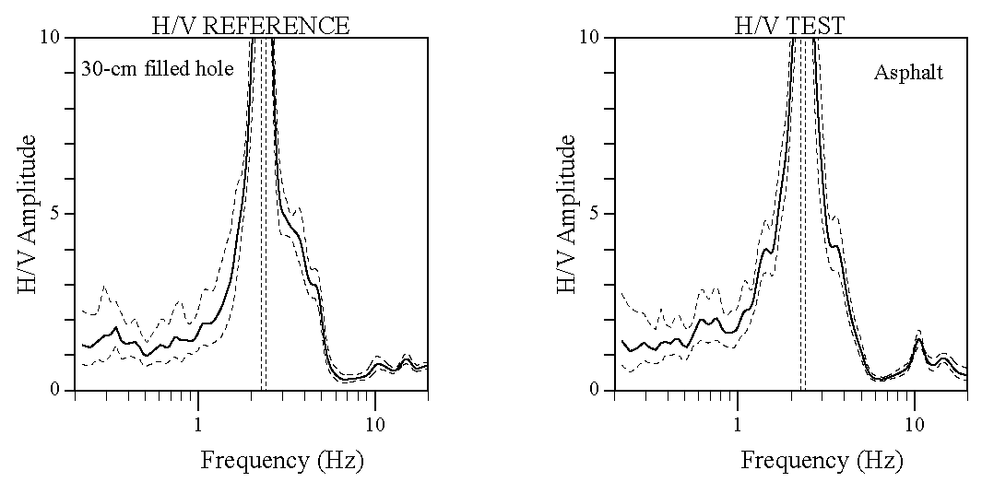
Figure 1. Comparison of the H/V curves obtained with and without asphalt, at the same site, showing no significant effect of the asphalt layer.

Artificial soil-sensor coupling
When an artificial interface is needed between the ground and the sensor, it is highly recommended that some tests be performed before doing the recordings in order to examine a possible influence of the chosen interface.
→ The use of a metal plate in-between the sensor and the ground does not modify the results.
→ In case of a steep slope that does not allow correct sensor levelling, the best solution is to install the sensor on a pile of sand or in a plastic container filled with sand.
→ In general, avoid "soft / non-cohesive" materials such as foam-rubber, cardboard, gravel (whether in a container or not), etc., to help setting up the sensor. See Figure 3 for a comparison with the sensor directly on the natural soil, or on a Styrofoam plate.

Sensor setting
→ The sensor should be installed horizontally as recommended by the manufacturer.
→ There is no need to bury the sensor, but it does not hurt if this is the case. It can be useful however, to set-up the sensor in a hole (no need to fill it) about its own size in order to get rid, for example, of the effect of a weak wind on grass. This would be effective only if there are no structures nearby, such as buildings or trees that might also induce some strong low frequency perturbations in the ground, due to the wind (see below).
→ Do not put any load on the sensor.
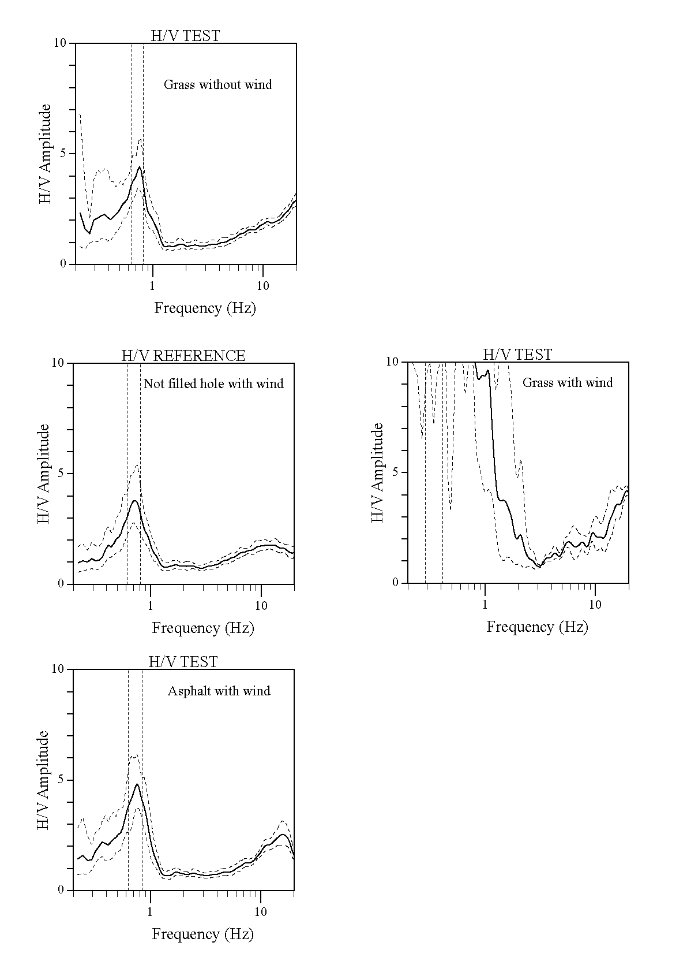

Figure 2. Comparison of the H/V curves obtained at the same site on grass with and without wind (top), and in a hole, on asphalt (bottom) and again on grass with wind. This comparison shows the strong effect of the wind combined with grass, whereas on asphalt or in a hole, the wind has no significant effect (if far away from any structure).
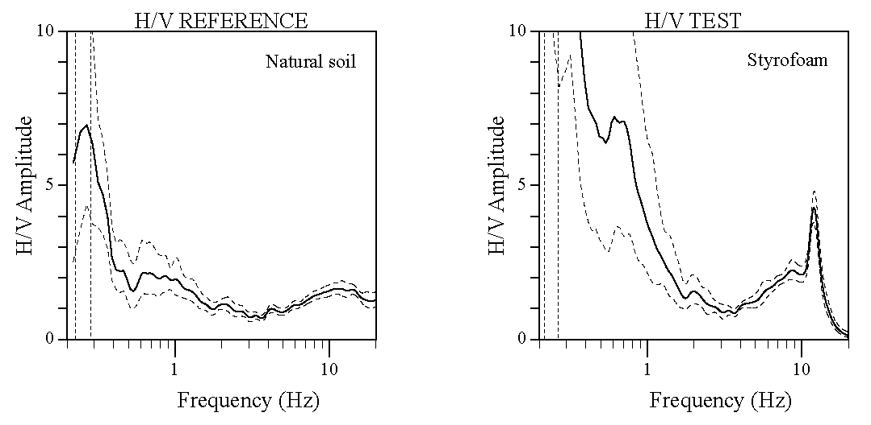
Figure 3. Comparison of the H/V curves obtained with and without a Styrofoam plate under the sensor, at the same site, showing a strong effect of the Styrofoam.

Nearby structures
→ Users are advised that recording near structures such as buildings, trees, etc., may influence the results: there is clear evidence that movements of the structures due to the wind may introduce strong low frequency perturbations in the ground. Unfortunately, it is not possible to quantify the minimum distance from the structure where the influence is negligible, as this distance depends on too many external factors (structure type, wind strength, soil type, etc.).
→ Avoid measuring above underground structures such as car parks, pipes, sewer lids, etc., these structures may significantly alter the amplitude of the vertical motion.

Weather conditions
→ Wind probably has the most frequent influence and we suggest avoiding measurements during windy days. Even a slight wind (approx. > 5 m/s) may strongly influence the H/V results by introducing large perturbations at low frequencies (below 1 Hz) that are not related to site effects. A consequence is that wind only perturbs low frequency sites.
→ Measurements during heavy rain should be avoided, while slight rain has no noticeable influence on H/V results.
→ Extreme temperatures should be treated with care, following the manufacturer's recommendations for the sensor and recorder; tests should be made by comparing night / day or sun / shadow measurements.
→ Low pressure meteorological events generally raise the low frequency content and may alter the H/V curve. If the measurements cannot be delayed until quieter weather conditions, the occurrence of such events should be noted on the measurement field sheet.

Disturbances
→ No influence from high voltage cables has been noted.
→ All kinds of short-duration local sources (footsteps, car, train,...) can disturb the results. The distance of influence depends on the energy of the source, on the soil conditions, etc., therefore it is not possible to give general minimum distance values. However, it has generally been observed, for example, that ambient vibration sources with short periods of high amplitude (e.g. fast highway traffic) influence H/V ratios if they are within 15-20 metres, but that more continuous sources (e.g. slow inner city traffic) only influence H/V ratios when they are much closer. Our experience is that it is the impulsiveness of the noise envelope that is crucial Therefore traffic is much less of a problem in a city than it is close to a highway, for example. Users are anyway encouraged to check recorded time series in the field when they perform measurements in a noisy environment.
→ Short-duration disturbances of the signal can be avoided during the H/V analysis by using an anti-trigger window selection to remove the transients. A consequence is that the time duration of the recordings should be increased in order to gather enough duration of “quiet” signal (see sections 2 and 3), unless, for example, only one train has perturbed the recordings.
→ Avoid measurements near monochromatic sources such as construction machines, industrial machines, pumps, etc.
→ The recording team should not keep its car engine running during recordings.

DATA PROCESSING STANDARD: J-SESAME SOFTWARE

This chapter is based on the following SESAME internal reports:
– Multi-platform H/V processing software J-SESAME, Deliverable D09.03 [3],
– J-SESAME User Manual, Version 1.07 [4],

J-SESAME is a JAVA application for providing a user-friendly graphical interface for the H/V spectral ratio technique, which is used in local site effect studies. The program uses the functions of automatic window selection and H/V spectral ratio by executing external commands. The automatic window selection and H/V process are standalone applications developed in Fortran. J-SESAME is mainly a tool for organising the input data, executing window selection and processing, and displaying the processing results. The software operates in Unix, Linux, Macintosh and Windows environments.

Details concerning system requirements and installation procedure are given in the J-SESAME user manual delivered with the software.

2.1 General design of the software
The general design of J-SESAME is based on a modular architecture. There are basically four main modules:
- browsing module,
- window selection module,
- processing module,
- display module.

The main functionalities are integrated through a graphical user interface, which is part of the browsing module. The display module is also tightly connected to the browsing module, as there is close interaction between the two modules due to the integrated code development in Java. Only two waveform data formats are accepted: GSE and SAF (SESAME ASCII Format), see J-SESAME user manual for more details.

2.2 Window Selection Module
Windows can be selected automatically or manually. The manual window selection mode can be used if the check-box labelled as “Manual window selection” (Figure 4) is active.

Besides manual selection directly from the screen, which is often the most reliable, but also the most time consuming method, an automatic window selection module has been introduced to enable the processing of large amounts of data. The objective is to keep the most stationary parts of ambient vibrations, and to avoid the transients often associated with specific sources (footsteps, close traffic). This objective is exactly the opposite of the usual goal of seismologists who want to detect signals, and have developed specific "trigger" algorithm to track the unusual transients. As a consequence, we have used here an "antitrigger" algorithm, which is exactly the opposite: it detects transients but it tries to avoid them.

The procedure to detect transients is based on a classical comparison between the short term average "STA", i.e., the average level of signal amplitude over a short period of time, denoted "tsta" (typically around 0.5 to 2.0 s), and the long term average "LTA", i.e., the average level of signal amplitude over a much longer period of time, denoted "tlta" (typically several tens of seconds).

In the present case, we want to select windows without any energetic transients: this means that we want the ratio sta/lta to remain below a small threshold value smax (typically around 1.5 – 2) over a long enough duration. Simultaneously, we also want to avoid ambient vibration windows with abnormally low amplitudes: we therefore also introduce a minimum threshold smin, below which the signal should not fall during the selected ambient vibration window.

There are also two other criteria that may be optionally used for the window selection:
- one may wish to avoid signal saturation – as saturation does affect the Fourier spectrum. As gain and maximum signal amplitudes are not mandatory in the header of SAF and GSE formats, the program looks for the maximum amplitude over the whole ambient vibration recording, and automatically excludes windows during which the peak amplitude exceeds 99.5 % of this maximum amplitude. By default, this option is turned on.
- in some cases, there might exist long transients (for instance related to heavy traffic, trains, machines, …) during which the sta/lta will actually remain within the set limits, but during which the ground motion may not be representative of real seismic ambient vibrations. Another option was therefore introduced to avoid "noisy windows", during which the lta value exceeds 80% of the peak lta value over the whole recording. By default, this option is turned off.

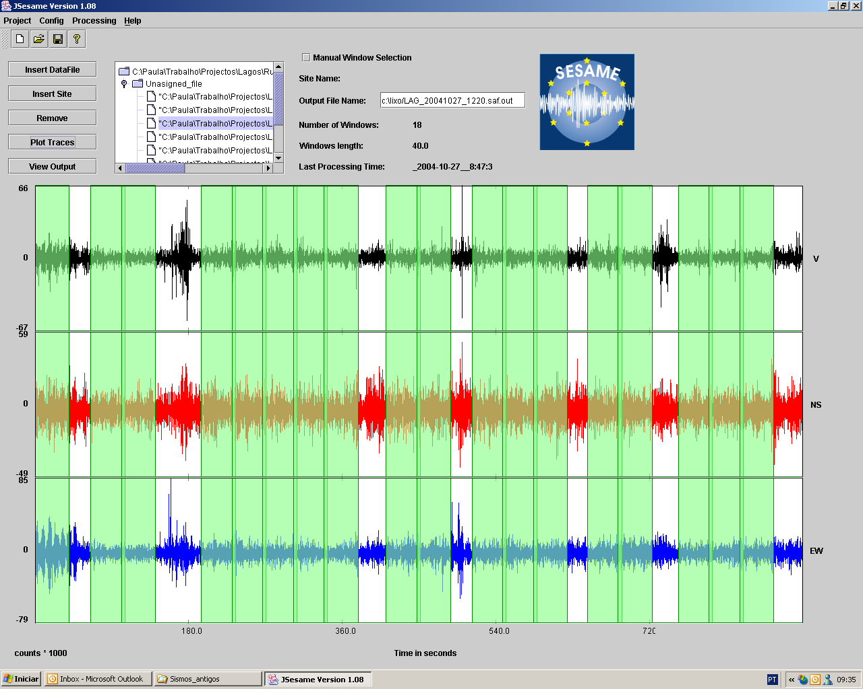
Figure 4. This figure shows the graphical user interface of J-SESAME. Selected windows are shown in green.

The program automatically looks for time windows satisfying the above criteria; when one window is selected, the program looks for the next window, and allows two subsequent windows to overlap by a specified amount "roverlap" (default value is 20%).

The window selection module has been written as an independent Fortran subroutine, for which:
- The input parameters are the selection parameters (tsta = STA window length; tlta = LTA window length; [smin, smax] = lower and upper allowed bounds for the sta/lta ratio; tlong = ambient vibration window length over which the sta/lta should remain within the bounds; yes/no (1/0) parameters for turning on or off the saturation and "noisy window" options; overlapping percentage allowed for two subsequent windows)
- The output parameters are the name of the ambient vibration file, the start and end times of each selected window, the recording status of each component : the main processing module then reads the ambient vibration file, and performs the H/V computation over each selected window.

Figure 5 shows an example where the same signal has been processed with and without the automatic window selection (that is the transient removal). This example shows that the peak on the H/V curve is much clearer when the transient removal is applied, and also that standard deviation is lower, especially at low frequencies.

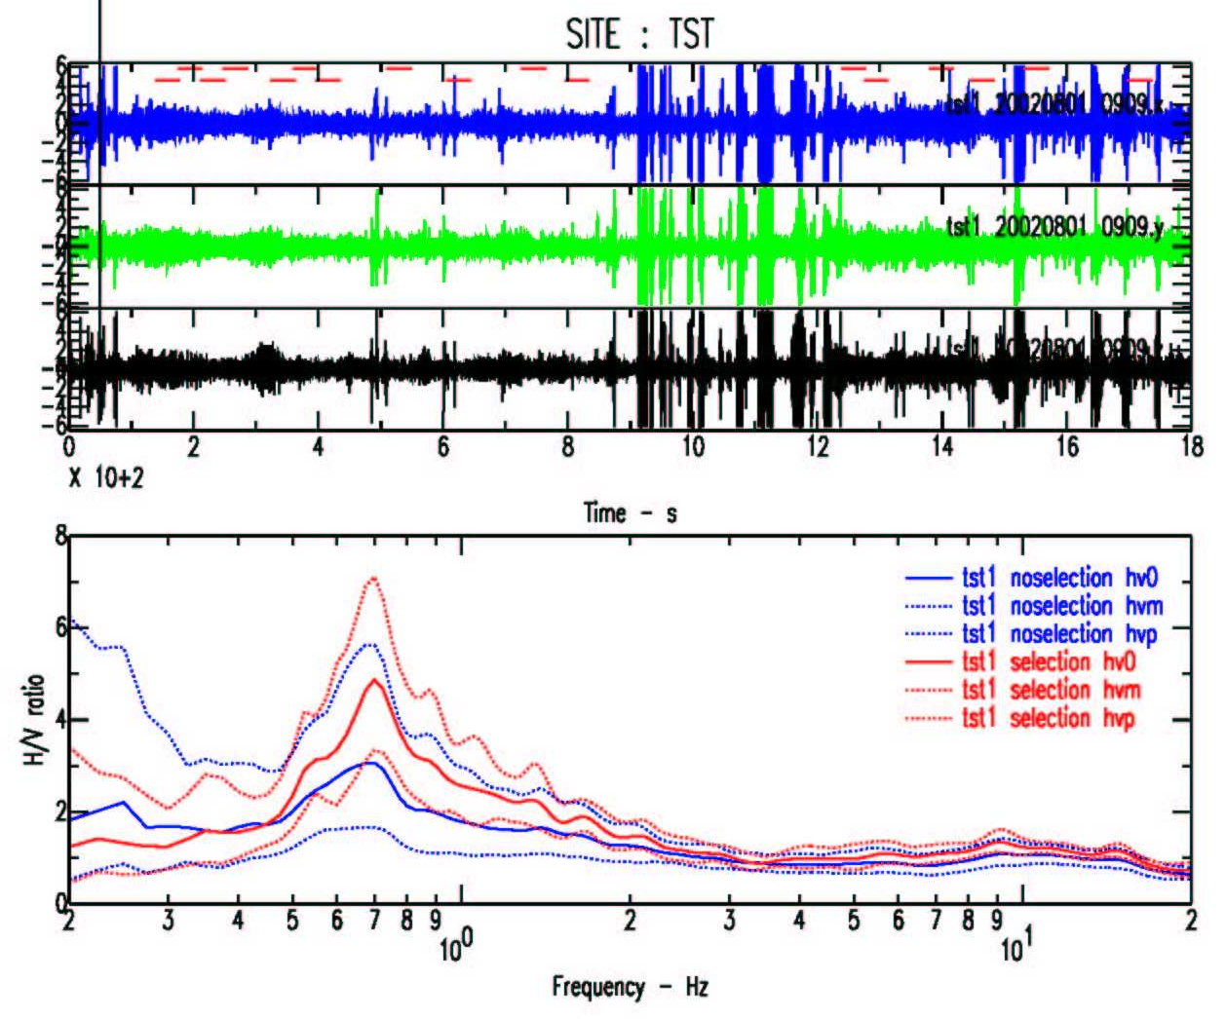

Figure 5. Signal (top) processed with (red curves bottom) or without (blue curves bottom) the automatic window selection (selected windows are indicated by the red segments on the top of the signal). The peak on the H/V curve is much clearer when the transient removal is applied, and also the standard deviation is lower, especially at low frequencies.

The choice of the window selection parameters should be carefully optimised before any automatic processing.

2.3 Computing H/V spectral ratio
The main processing module is developed in FORTRAN90. It performs H/V spectral ratio computations and the other associated processing such as DC-offset removal, filtering, smoothing, merging of horizontal components, etc., on the selected windows for individual files or alternatively on several files as a batch process. The instrument response is assumed to be removed by the user (in the case of identical components H/V ratios should not be affected by the instrument response). Main functionalities of the processing module are described below:
- FFT (including tapering)
- Smoothing with several options. The Konno & Ohmachi smoothing is recommended as it accounts for the different number of points at low frequencies. Be careful with the use of constant bandwidth smoothing, which is not suitable for low frequencies.
- Merging two horizontal components with several options. Geometric mean is recommended.
- H/V Spectral ratio for each individual window
- Average of H/V ratios
- Standard deviation estimates of spectral ratios

Details of the different options are to be found in the Appendix of the J-SESAME User Manual. The parameter settings for the above options are controlled through an input file.

The processing module is applied according to the selected nodes in the tree. If the selected node is a site, then all the selected windows of the data-files collected for this site will be used for computing the average H/V spectral ratio. Output for each window can be also obtained by setting up the configuration parameters of the processing module. Batch processing will be performed when several sites or data-files are selected.

2.4 Showing output results
By pressing the <View Output> button (Figure 4) the user can navigate through three dialogue boxes. The first dialogue box (Figure 6) shows the H/V spectral ratio of the merged horizontal components, as well as the plus and minus one standard deviation curves. The second dialogue box shows the H/V spectral ratio for each one of the NS and EW components. The third one (Figure 7) shows the spectral ratio of the merged (H), NS and EW horizontal components and the spectra of V, NS and EW for each individual window, only if “output single window information” is selected in the configuration parameter of the processing module.

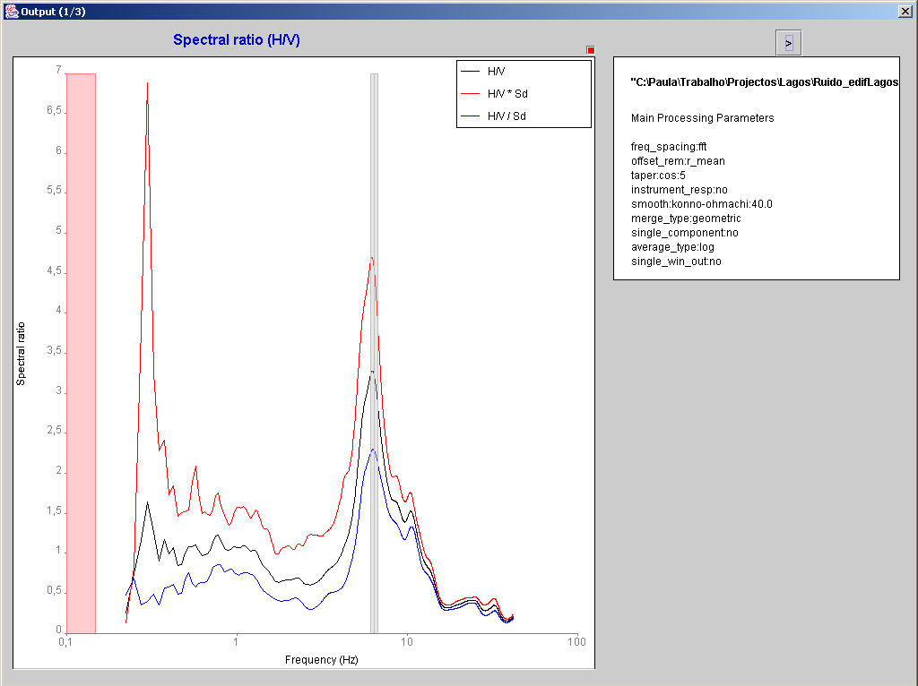

Figure 6. H/V ratio for the merged horizontal components (mean in black, mean multiplied and divided by 10^{σ(logH/V)}, in red and blue). The pink strip shows the frequency range where the data has no significance, due to the sampling rate and the window length. The grey strip represents the mean f₀, plus and minus the standard deviation. It is calculated from the f₀ of each individual window.

2.5 Setting graph properties and creating images of the output results
For each graph shown (for example as in Figure 6 and 7) there is a small red box in the upper right corner without any label. By clicking there the properties and scale of the graph can be modified and images of the graph can be created. The button <Properties and series> pops up a dialogue box where line type, width and colour can be changed for each spectral curve. The button <Scales> pops up a dialogue box where the minimum, maximum and scale type for each one of the vertical and horizontal axes can be modified. The button <Save> allows an image of the graph to be created.

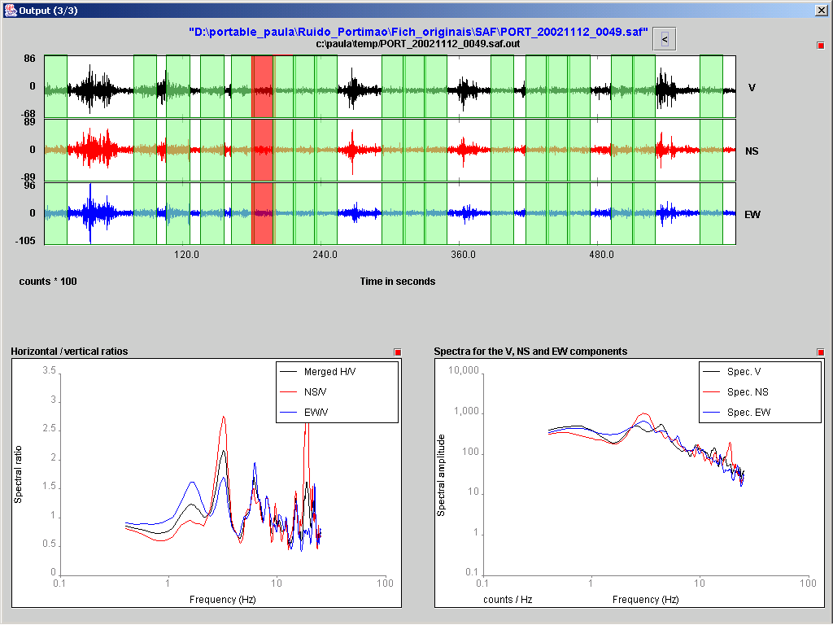

Figure 7. Result for individual windows: H/V ratios and spectra shown are derived from the signal displayed in the red window.

3. INTERPRETATION OF RESULTS

Table 2. Definitions of the parameters used in this section.

- l_{w} = window length
- n_{w} = number of windows selected for the average H/V curve
- n_{c} = l_{w} . n_{w}. f₀ = number of significant cycles
- f = current frequency
- f_{sensor} = sensor cut-off frequency
- f₀ = H/V peak frequency
- σ_{f} = standard deviation of H/V peak frequency (f₀ ± σ_{f})
- ε (f₀) = threshold value for the stability condition σ_{f} < ε(f₀)
- A₀ = H/V peak amplitude at frequency f₀
- A_{H/V} (f) = H/V curve amplitude at frequency f
- f⁻ = frequency between f₀/4 and f₀ for which A_{H/V}(f⁻) < A₀/2
- f⁺ = frequency between f₀ and 4f₀ for which A_{H/V}(f⁺) < A₀/2
- σ_{A} (f) = standard deviation of A_{H/V} (f), σ_{A} (f) is factor by which the mean A_{H/V}(f) curve should be multiplied or divided
- σ_{logH/V} (f) = standard deviation of the logA_{H/V}(f) curve, σ_{logH/V} (f) is an absolute value which should be added or subtracted to the mean logA_{H/V}(f) curve
- θ (f₀) = threshold value for the stability condition σ_{A}(f) < θ(f₀)
- V_{s,av} = average S-wave velocity of the total deposits
- V_{s,surf} = S-wave velocity of the surface layer
- h = depth to bedrock
- h_{min} = lower-bound estimate of h

3.1 Underlying assumptions
As detailed in Appendix B, the main information looked for within the H/V ratio is the fundamental natural frequency of the deposits, corresponding to the peak of the H/V curve. While the reliability of its value will increase with the sharpness of the H/V peak , no straightforward information can be directly linked to the H/V peak amplitude A₀. This latter value may however be considered as indicative of the impedance contrasts at the site under study: large H/V peak values are generally associated with sharp velocity contrasts.

Figure 8 shows a comparison between the H/V ratio of ambient vibrations and the standard spectral ratio of earthquakes using a reference site. The comparison is performed using all the sites investigated in the framework of the SESAME project. The top part of the figure compares the value of the fundamental natural frequency f₀ derived using both methods. An overall good agreement can be observed for the frequency values. The bottom part of Figure 8 compares the value of the peak amplitude A₀. This comparison shows that it is not scientifically justified to use A₀ as the actual site amplification. However, there is a general trend for the H/V peak amplitude to underestimate the actual site amplification. In other words, the H/V peak amplitude could generally be considered as a lower bound of the actual site amplification.

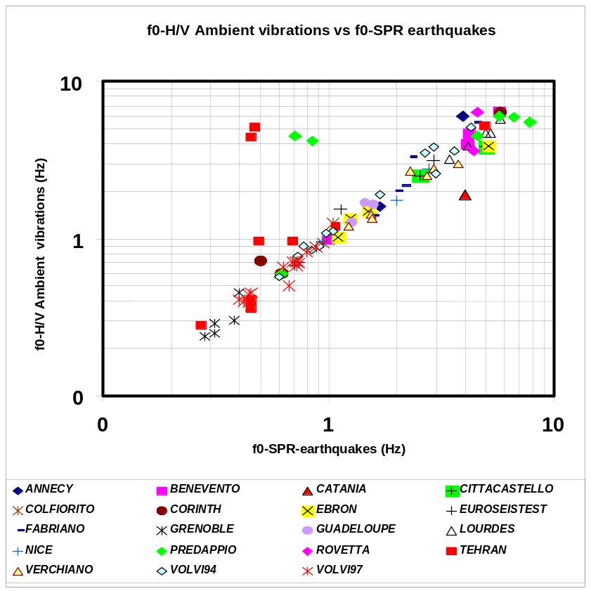
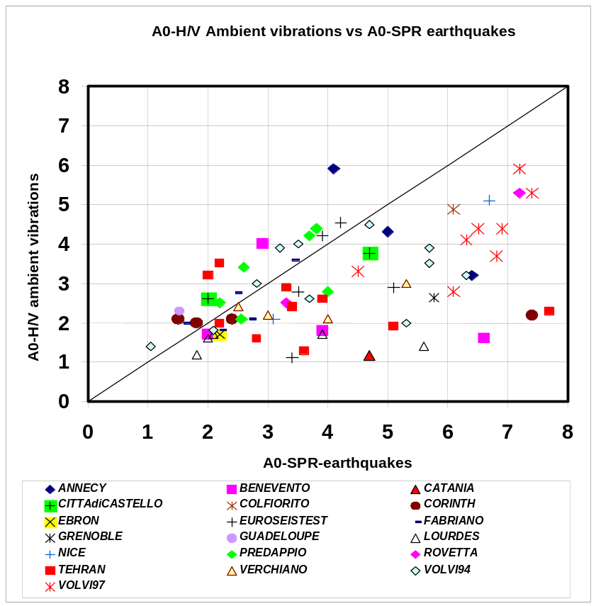

Figure 8. Comparison between H/V ratio of ambient vibrations and standard spectral ratio of earthquakes. Top: comparison of the frequencies f₀, bottom: comparison of the amplitudes A₀.

The following interpretation guidelines are mainly linked with the clarity and stability of the H/V peak frequency value. The "clarity" however is related at least partly to the H/V peak amplitude (see below). While there are very clear situations where the risk of mistake is close to zero, one may also face cases (more than 50% in total) where the interpretation is uneasy and must call to some extent on "expert judgement": the following guidelines propose a framework for such an expert judgement, trying to minimise the subjectivity – which, however, can never be completely avoided.

3.2 Conditions for reliability
The first requirement, before any extraction of information and any interpretation, concerns the reliability of the H/V curve. Reliability implies stability, i.e., the fact that actual H/V curve obtained with the selected recordings, be representative of H/V curves that could be obtained with other ambient vibration recordings and/or with other physically reasonable window selection.
Such a requirement has several consequences :
- In order for a peak to be significant, we recommend checking that the following condition is fulfilled : f₀ > 10 / l_{w}. This condition is proposed so that, at the frequency of interest, there be at least 10 significant cycles in each window (see Table 1). If the data allow – but this is not mandatory –, it is always fruitful to check whether a more stringent condition [ f₀ > 20 / l_{w}], can be fulfilled, which allows at least ten significant cycles for frequencies half the peak frequency, and thus enhances the reliability of the whole peak.
- A large number of windows and of cycles is needed: we recommend that, when using the automatic window selection with default parameters, the total number of significant cycles : n_{c} = l_{w} . n_{w} .f₀ be larger than 200 (which means, for instance, for a peak at 1 Hz, that there be at least 20 windows of 10 s each; or, for a peak at 0.5 Hz, 10 windows of 40 s each), see Table 1 for other frequencies of interest. In case no window selection is considered (all transients are taken into account), we recommend, for safety, this minimum n_{c} number of cycles be raised around 2 times at low frequencies (i.e., up to 400), and up to 4 to 5 times at high frequencies, where transients are much more frequent (i.e., up to 1000).
- An acceptably low level of scattering between all windows is needed. Large standard deviation values often mean that ambient vibrations are strongly non-stationary and undergo some kind of perturbations, which may significantly affect the physical meaning of the H/V peak frequency. Therefore it is recommended that σ_{A}(f) be lower than a factor of 2 (for f₀ > 0.5 Hz), or a factor of 3 (for f₀ < 0.5 Hz), over a frequency range at least equal to [0.5f₀, 2f₀].

Therefore, in case one particular set of processing parameters does not lead to satisfactory results in terms of stability, we recommend reprocessing the recordings with some other processing parameters. As conditions for fulfilling items i , ii and iii above often lead to opposite tuning for some parameters (see section 2.), it may be impossible in some cases: the safest decision is then to go back to the site and perform new measurements of longer duration and/or with more strictly controlled experimental conditions.

In addition, one must be very cautious if the H/V curve exhibits amplitude values very different from 1 (i.e., larger than 10, or lower than 0.1) over a large frequency range (i.e., over two octaves): in such a case, it is very likely that the measurements are bad (malfunction in the sensor or the recording system, very strong and close artificial ambient vibration sources, for instance), and should be redone ! It is mandatory to check the original time domain recordings first.

In the following interpretation guidelines, we assume that these reliability conditions are met; if not, some reprocessing with other computational parameters should be attempted to try to meet them, or some additional measurements made. If none of these two options leads to satisfactory results, then the results should be considered with caution, and some reliability warning should be issued in the final interpretation.

3.3 Identification of f₀

3.3.1 Clear peak
The clear peak case is met when the H/V curve exhibits a "clear, single" H/V peak.
- The "clarity" concept may be related to several characteristics: the amplitude of the H/V peak and its relative value with respect to the H/V value in other frequency bands, the relative value of the standard deviation σ_{A} (f), and the standard deviation σ_{f} of f₀ estimates from individual windows.
- the property "single" is related to the fact that in no other frequency band, does the H/V amplitude exhibit another "clear" peak satisfying the same criteria.

We propose the following quantitative criteria for the "clarity"
Amplitude conditions:
  - there exists one frequency f⁻, lying between f₀/4 and f₀, such that A₀ / A_{H/V} (f⁻) > 2
  - there exists another frequency f⁺, lying between f₀ and 4.f₀, such that A₀ / A_{H/V} (f⁺) > 2
  - A₀ > 2
Stability conditions:
  - the peak should appear at the same frequency (within a percentage ± 5%) on the H/V curves corresponding to mean + and – one standard deviation.
  - σ_{f} lower than a frequency dependent threshold ε(f), detailed in Table 3.
  - σ_{A} (f₀) lower than a frequency dependent threshold θ(f), also detailed in Table 3.

Table 3 gives the frequency dependent threshold values for the above given stability conditions v) σ_{f} < ε(f), and vi) σ_{A} (f₀) < log θ(f), or σ_{logH/V} (f₀) < θ(f).

Table 3. Threshold values for stability conditions.
Frequency range [Hz] | < 0.2 | 0.2 – 0.5 | 0.5 – 1.0 | 1.0 – 2.0 | > 2.0
ε (f₀) [Hz] | 0.25 f₀ | 0.20 f₀ | 0.15 f₀ | 0.10 f₀ | 0.05 f₀
θ (f₀) for σ_{A} (f₀) | 3.0 | 2.5 | 2.0 | 1.78 | 1.58
log θ (f₀) for σ_{logH/V} (f₀) | 0.48 | 0.40 | 0.30 | 0.25 | 0.20

For the property "single", we propose that none of the other local maxima of the H/V curve fulfil all the above quantitative criteria for the "clarity".

If the H/V curves for a given site fulfil at least 5 out of these 6 criteria, then the f₀ value can be considered as a very reliable estimate of the fundamental frequency. If, in addition, the peak amplitude A₀ is larger than 4 to 5, one may be almost sure that there exists a sharp discontinuity with a large velocity contrast at some depth.

However, one has, in any case, to perform the two following checks:
- the frequency f₀ is consistent with the sensor cut-off frequency f_{sensor} and sensitivity : if f₀ is lower than1 Hz, while the sensor used is a high frequency velocimeter, check the results with the procedure indicated in 3.3.2.b.
- this sharp peak does not have an industrial origin (cf. 3.3.2.a).
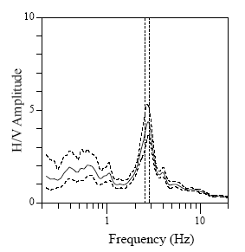
Window length l_{w} [s]Number of windows n_{w}Number of significant cycles n_{c}Frequency statistics from individual windowsf₀ [Hz]σ_{f} [Hz]A₀σ_{A}(f₀)411415612.720.114.41.2

Figure 9. Example of a clear H/V curve, that fulfils all the criteria for "reliability" and "clarity" given in sections 3.2 and 3.3.1.

3.3.2 "Unclear" cases

3.3.2-a Sharp peaks and Industrial origin
It often occurs in urban environments that H/V curves exhibit local narrow peaks – or troughs. In most cases, such peaks or troughs have an anthropic (usually industrial) origin, related to some kind of machinery (turbine, generators, ...).
Such perturbations are recognised by two general characteristics
- They may exist over a significant area (in other terms, they can be seen up to distances of several kilometres from their source).
- As the source is more or less "permanent" (at least within working hours), the original (non smoothed) Fourier spectra should exhibit sharp peaks .

Several kinds of checks are therefore recommended :
- Have a look at the raw spectra from each individual window : if they all exhibit a sharp peak (often on the 3 components together), at this particular frequency, there is a 95 % chance that this is anthropic "forced" ambient vibration and it should not be considered in the interpretation.
- Another check consists of reprocessing with less and less smoothing: in the case of industrial origin, the H/V peak should become sharper and sharper (while this is not the case for a "site effect" peak linked with the soil characteristics). In particular, checks with "linear", "box" smoothing with smaller and smaller bandwidth should result in "box-like" peaks having exactly the same bandwidth as the smoothing.
- If other measurements have been performed in the same area, determine whether a peak exists at the same frequencies with comparable sharpness (the amplitude of the associated peak, even for a fixed smoothing parameter, may vary significantly from site to site, being transformed sometimes into a trough).
- Another very effective check is to apply the random decrement technique (Dunand et al., 2002) to the ambient vibration recordings in order to derive the "impulse response" around the frequency of interest: if the corresponding damping is very low (say, below 5%), an anthropic origin may be assumed almost certainly, and the frequency should not be considered in the interpretation.
- Whenever it is hard to reach a conclusion from the previous tests and this information is important, it is often very instructive to perform continuous measurements (over 24 h : day + night, or over one week: working days + week-end) to check whether these peaks also exist during non-working hours. There are, however, many plants that work 24h a day, 7 days a week: the test will not be conclusive in such a case, but it should be possible to identify such a plant with a minimum knowledge of the local industrial activity.

If any of the proposed checks does suggest an industrial origin, then the identified frequency should be completely discarded: it has no link with the subsurface structure.

Note : It may happen that the spurious frequency of industrial origin coincides with, or is not far from, a real site frequency. The existence of such artefacts may then alter the estimation of the actual site frequency f₀; as much as possible, it is then preferable to perform measurements outside working hours to avoid this spurious peak, or to apply severe band-reject filters to the microtremor recordings in order to totally eliminate the artefact and its effects.

3.3.2-b Unclear low frequency peaks [criterion i) and possibly ii) not fulfilled]
There exist a number of conditions where the H/V curve exhibits a fuzzy, unclear low frequency peak (i.e., at frequencies lower than 1 Hz), or a broad peak that does not satisfy all the criteria above, especially the amplitude criteria.
It may have several origins (nonexclusive of one another)
- a low frequency site with either moderate impedance contrast (lower than approx. 4) at depth, or a velocity gradient, or a low level of low frequency ambient vibrations (for instance in continental areas)
- wind blowing during recording time, especially in the case of non-optimal recording conditions (for instance proximity of trees or buildings)
- measurements performed during a meteorological perturbation that may significantly enhance the low frequency content and alter the H/V ratio.
- a bad soil-sensor coupling, for instance on very wet soils (after rain), or with grass, or with a non-satisfactory plate in between the sensor and the soil
- low frequency artificial ambient vibration sources (such as heavy trucks / public works machines) at close to intermediate distance (within a few hundred meters)
- inadequate smoothing parameters (smoothing with a constant bandwidth may completely or partially erase low frequency peaks)
- inadequate sensor with very low sensitivity at low frequency.

Distinguishing between these various possibilities is not easy. The following tests / checks may however help to decide whether the "unclear" low frequency peak is indeed a site characteristic :
- Consider the geology of the site: if it is on rock, it is likely that the low frequency fuzzy peak is an artefact; if it is on sedimentary deposits, there might exist low frequency effects, due either to very soft surface layers, or to stiff but thick deposits. In general, very soft layers (such as in Mexico City) result in clear peaks because of large impedance contrasts (at least, approx. 4), while unclear H/V peaks at low frequency are more likely for thick, stiff sedimentary deposits.
- Check the weather bulletins corresponding to the recording period and the measurement field sheets.
- Check the low frequency asymptote (limit value of H/V ratio when frequency is close to zero): if the asymptotic value is significantly larger than 2, some low frequency artefacts due to wind , or traffic, or bad sensor, are likely.
- Check the cut-off frequency f_{sensor} of the sensor used.
- Check whether or not a peak around f₀ also appears on the mean ± one standard deviation curves (item iv in 3.3.1). If not, reprocess the data with longer windows and/or more stringent window selection criteria (in this case the standard deviation σ_{A} (f) is probably too large and has to be reduced).
- Check the smoothing parameters and reprocess the data with i) proportional bandwidth and ii) less smoothing: if this improves the clarity and stability of the low-frequency peak, it is a hint that there are high chances it is due to site conditions ; however, if even with this reprocessing, the criteria of 3.3.1 are not fulfilled, it is recommended that the site be re-measured with longer recordings.
- Have a look at H/V curves from individual windows, at the corresponding H and V Fourier spectra, and at the corresponding time histories. Some of them may be eliminated, some other windows may be added (document the reasons for each window), which may lead to a clearer low frequency peak satisfying all criteria of 3.3.1.

3.3.2-c Broad peak case or multiple peak case
In some cases, the H/V curve may exhibit a broad peak, or a multiplicity of local maxima, none of which fulfils the above criteria i, ii and possibly v (3.3.1).
In each of these cases, the first check to perform is to change the smoothing parameters: in case of a broad peak, decrease the smoothing bandwidth; in the multiple peak case, increase the smoothing bandwidth.
In this latter case however, another mandatory check consists of investigating the possible industrial origin of any one of these peaks (see 3.3.2.a).

It may sometimes happen that other "acceptable" processing parameters allow the broad or multiple peaks to be transformed into a "clear" H/V curve according to the criteria of 3.3.1. This is, however, rather rare.
- If the broad nature seems stable with a rather small standard deviation, then one may consider the possible link with a sloping underground interface (see below 3.4 and appendix B).
- With large smoothing, a multiple peak curve may always be transformed into a "broad peak" or "plateau-like" curve. Smoothing parameters that are too large are nevertheless not recommended. Since our experience taught us the scarcity of such cases, and their links, very often, to unsatisfactory recordings, we recommend, in such cases, either that the H/V results for the site be discarded, or that the measurements be repeated.

3.3.2-d Two peaks case
In some cases, the H/V curve may exhibit two peaks satisfying the above criteria (3.3.1); this is, however, rather rare.

Theoretical and numerical investigations have shown that such a situation occurs for two large impedance contrasts (say, around 4 minimum for each), at two different scales: one for a thick structure, and the other one for a shallow structure. The two frequencies, f₀ and f₁ (with f₀ < f₁), may then be interpreted as characteristics at each scale, f₀ being the fundamental frequency.

In order to check whether this is actually the case, the following checks are recommended:
- check the geology of the site and the possibility of a) shallow, soft deposits, b) thick, rather stiff sediments (or soft rock) and c) very hard underlying bedrock at depth.
- Reprocess the data with other smoothing parameters: the peaks should be stable and withstand broader and narrower smoothing (around the recommended default values) ; consider in particular the possibility that one of these peaks (generally at the higher frequency) may have an industrial origin (cf. 3.3.2.a).
- The statistics on several hundred measured sites and a number of theoretical cases show that the two contrasts should be at very different scales, which means that the two frequencies f₁ and f₀ should be sufficiently different so that both peaks fulfil the clarity criteria.

3.4 Interpretation of f₀ in terms of site characteristics
After having analysed and checked the H/V curves as indicated in the previous section, the next step is to interpret the H/V curve, and in particular the peak frequency(ies) f₀ (and f₁), in terms of site characteristics.
- When f₀ is clear (case 3.3.1) and does not have an industrial origin, then there is a quasi-certitude that the site under study presents a large impedance contrast (at least, approx. 4) at some depth, and is very likely to amplify the ground motion. f₀ is the fundamental frequency of the site; there is around 80% chance that the actual site amplification for the Fourier spectra, around the fundamental frequency f₀, is larger than the H/V amplitude A₀; amplification starts at f₀, but may occur at higher frequencies even though the H/V amplitude remains small. If the local thickness is known, the average S-wave velocity of the surface layer may be estimated with the formula V_{S,av} ≈ f₀ . 4h ; if a reliable estimate of the S-wave velocity V_{S,surf} is available close to the surface, then a lower bound estimate of the thickness may be obtained with the formula h_{min} ≈ V_{S,surf} / 4.f₀. This conclusion holds, obviously, even in the case of a rock site: in that case, the existence of a clear H/V peak (generally at high frequencies) is proof of the existence of significant weathering at rock surface.

- When there exist two clear frequencies f₀ and f₁ satisfying the criteria described in 3.3.2d, it is likely that a) the surface velocity is low, b) the deep bedrock is very hard, and c) there exist two large impedance contrasts (at least, approx. 4) at two different scales, so that the amplification should be significant over a broad frequency range starting at f₀ and extending beyond f₁. If the local total thickness is known, the average S-wave velocity of the surface layers may be estimated with the formula V_{S,av} ≈ f₀ . 4h ; if a reliable estimate of the S-wave velocity V_{S,surf} is available close to the surface, then a lower bound estimate of the thickness of the topmost layer may be obtained with the formula h_{1,min} ≈ V_{S,surf} / 4.f₁ .

- Frequencies of industrial origin associated with sharp peaks must be completely discarded for an interpretation in terms of site characteristics.

- In the case of an "unclear" low frequency peak (f₀ < 1 Hz), the safest attitude is to refrain from deriving quantitative interpretations from the H/V curve. If the same observation is consistent over several measurement sites in the same area, and if stiff sediments are present at this site, then we recommend going back in the field and to perform additional measurements – if possible during night time and/or under quiet weather conditions, with a low frequency velocity sensor and over long periods of time. The low frequency might then be extracted in a clearer manner. In any case, one must then keep in mind the possibility, at such a site, of low frequency amplifications: the safest way to investigate the reality of such low frequency amplification is to install temporary stations equipped with broad band velocity sensors in continuous recording mode, including one on a nearby "reference" (rock) site, and to evaluate the classical site to reference spectral ratios from earthquake recordings (regional or teleseismic events are perfectly suited for showing low frequency amplification).

- If the H/V curve exhibits a broad maximum, whatever the processing (see 3.3.2.c), then it is not easy to extract any information for the maximum frequency of this broad peak, since this estimate may significantly vary with different processing parameters (smoothing type, bandwidth, etc.). However, it may be that such a broad peak is due to the presence of an underground sloping interface between softer and harder layers: if other recordings are available in the same area, one is then invited to check whether clearer peaks are observed in the vicinity, and whether the associated frequencies a) exhibit significant variations from site to site and b) lie within the frequency range of the broad peak. If all these conditions are fulfilled, then there are large chances that the underground structure of the site under study exhibits significant lateral variations, which lead to significant 2D or 3D effects. Such "broad peak" or "plateau-like" H/V curves are indeed observed on many valley edges.

- If the H/V curve exhibits amplitude values very different from 1 (i.e., up to 10, or as low as 0.1) over a large frequency range, it is very likely that the measurements are bad (malfunction in the sensor or the recording system, very strong and close artificial ambient vibration sources), and should be redone!

- Finally, if the H/V curve is flat (i.e., has values lying between around 0.5 and 2.0, without any clear peak), it is very likely that the local underground structure does not exhibit any sharp impedance contrast (at least, approx. 4) at any depth. It does not necessarily mean, however, that there is no site amplification; there are several examples of sites with low frequency amplification and flat H/V curve (see the example of Tehran-ABM site, in Appendix A.2). One should not be too hasty therefore in interpreting flat H/V curve in terms of a no-amplification site: this can be done only for rock sites. However, such situations of a flat curve on non-rock sites correspond to less that 5% of the total number of sites studied, as can be seen on Figure 8, section 3.1.

ACKNOWLEDGEMENTS

The SESAME project has been supported by the European Commission – Research General Directorate (Project No. EVG1-CT-2000-00026) and by the Swiss Federal Office for Education and Science (OFES No. 00.0085-1). We would like to kindly thank Benoît Le Brun, Hanan Nimry, Michael Schmitz and Bill Stephenson for their constructive review of the guidelines text.

REFERENCES

All deliverables and scientific papers stemming from the SESAME project are available on the project web-site at http://sesame-fp5.obs.ujf-grenoble.fr/index.htm
Atakan K., A-M. Duval, N. Theodulidis, P-Y. Bard and the SESAME-Team. 2004, On the reliability of the H/V Spectral Ratio Technique, ICSDEE & ICEGE, Berkeley, CA, USA.
Atakan K., A.-M. Duval, N. Theodulidis, B. Guillier, J.-L. Chatelain, P.-Y. Bard and SESAME-Team. 2004. The H/V spectral ratio technique: experimental conditions, data processing and empirical reliability assessment. 13th world conference in Earthquake Engineering, Vancouver, Paper # 2268.
Bard P.-Y., and SESAME participants, 2004. The SESAME project: an overview and main results. Proceedings of the 13th World Conference in Earthquake Engineering, Vancouver, August 2004, Paper # 2207.
Bard P.-Y., 1998. Microtremor measurements: A tool for site effect estimation ? Proceeding of the Second International Symposium on the Effects of Surface Geology on Seismic Motion. Yokohama, Japan, 3. pp. 1251-1279.
Bonnefoy-Claudet S., C. Cornou, J. Kristek, M. Ohrnberger, M Wathelet, P.-Y. Bard, D. Fäh, P. Moczo, F. Cotton, 2004. Simulation of seismic ambient vibrations: I. H/V and array techniques on canonical models. 13th world conference in Earthquake Engineering, Vancouver, Paper # 1120.
Cornou, C., G. Di Giulio, M. Ohrnberger, J. Kristek, M. Wathelet, 2004. Simulated Vs observed seismic ambient noise in the Colfiorito basin: site effect estimation and noise wavefield characteristics. XXIXth European Seismological Commission, Session F3, September 2004.
Cornou C., J. Kristek, S. Bonnefoy-Claudet, D. Fäh, P.-Y. Bard, P. Moczo, M. Ohrnberger, M Wathelet, 2004. Simulation of seismic ambient vibrations: II. H/V and array techniques for real sites. Proceedings of the 13th World Conference on Earthquake Engineering, Vancouver, Canada, August 2004, Paper # 1130.
Cultrera G., R. Azzara, F. Cara, R. d’Anna, G. Di Giulio, M. S. Giammarinaro, G. Passafiume, A. Rovelli and P. Vallone, 2004. Microtremor Measurements in Palermo, Italy: a comparison with macroseismic intensity and earthquake ground motion. Proceedings of the 13th World Conference on Earthquake Engineering, Vancouver, August 2004, Paper # 915.
Dubos, N., A. Souriau, C. Ponsolles, J.-F. Fels and G. Sénéchal, 2003. Etude des effets de site dans la ville de Lourdes (Pyrénées, France) par la méthode des rapports spectraux. Bull. Soc. Géol. Fr., 174-1, 33-44.
Dubos, N., 2003. Contribution à l'évaluation du risque sismique dans les Pyrénées Centrales. Thèse de l'Université Paul Sabatier (Toulouse III), 210 pages.
Dunand F., P.-Y. Bard, J.-L. Chatelin, Ph. Guéguen, T. Vassail, M.N. Farsi. 2002. Damping and frequency from randomec method applied to in-situ measurements of ambient vibrations: Evidence for effective soil structure interaction. 12th European Conference on Earthquake Engineering, London. Paper # 869.
Duval A.-M., J.-L. Chatelain, B.Guillier and SESAME Project WP02 Team, 2004. Influence of experimental conditions on H/V determination using ambient vibrations (noise), Proceedings of the 13th World Conference on Earthquake Engineering, Vancouver, August 2004, Paper # 306.
Duval A.-M., J.-L. Chatelain, B. Guillier and the SESAME WP02 Team. 2004, Influence of experimental conditions on H/V determination using ambient vibrations (noise), ICSDEE & ICEGE, Berkeley, CA, USA.
Kanai K. and T. Tanaka, 1961. On microtremors. VIII. Bulletin of the Earthquake Research Institute, 39- 97-114.
Koller M. G., J.-L. Chatelain, B. Guillier, A.-M. Duval, K. Atakan, C. Lacave, P.-Y. Bard and the SESAME participants, 2004. Practical user guidelines and software for the implementation of the H/V ratio technique : measuring conditions, processing method and results interpretation, 13th World Conference on Earthquake Engineering, Vancouver, Paper # 3132.
Konno K. and T. Ohmachi, 1998. Ground motion characteristics estimated from spectral ratio between horizontal and vertical components of microtremors. Bull. seism. Soc. Am., 88-1, 228-241.
Kudo K., 1995. Practical estimates of site response. State-of-the- art report. Proceedings of the fifth Internationnal Conference on Seismic Zonation. Nice, France.
Malischewsky, P., and F. Scherbaum, 2004;Love's formula and H/V ratio (ellipticity) of Rayliegh waves, Wave motion, 40-1, 57-67..
Nakamura Y., 1989. A method for dynamic characteristics estimation of subsurface using microtremor on the ground surface. Quaterly Report Railway Tech. Res. Inst., 30-1, 25-30.
Nogoshi M. and T. Igarashi, 1971. On the amplitude characteristics of microtremor (part 2) (in japanese with english abstract). Jour. Seism. Soc. Japan, 24, 26-40.
Panou A. A. , N. P. Theodulidis, P. M. Hatzidimitriou , A. S. Savvaidis and C. B. Papazachos, Reliability of ambient noise horizontal-to-vertical spectral ratio in urban environment: The case of Thessaloniki city (Northern Greece), PAGEOPH, 2005 (in press).
Panou A. A. , N. Theodulidis , P. Hatzidimitriou , K. Stylianidis and C.B. Papazachos, Ambient noise horizontal-to-vertical spectral ratio in site effects estimation and correlation with seismic damage distribution in urban environment: The case of the city of Thessaloniki (Northern Greece), Soil Dyn. & Earthq. Engin., 2004 (accepted for publication).
SESAME European project, 2002. Controlled instrumentation specification, Deliverable D01.02.
SESAME European project, 2003. Nature of noise wavefield. Deliverable D13.08.
SESAME European project, 2003. H/V technique : experimental conditions, Deliverable D08.02
SESAME European project, 2003. Multi-platform H/V processing software J-SESAME. Deliverable D09.03.
SESAME European project, 2004. J-SESAME User Manual, Version 1.08.
SESAME European project, 2004. Report on parameter studies. Deliverable D12.09.
SESAME European project, 2004. Overall comparisons for test sites. Deliverable D17.10.
Stephenson, W.R., 2003. Factors bounding prograde rayleigh-wave particle motion in a soft-soil layer, Proceedings of the 2003 Pacific Conference on Earthquake Engineering, 13-15 February 2003, Christchurch, New-Zealand, Paper # 56, 8 pages
Teves-Costa, P., L. Senos and C.S. Oliveira, 2004. Correlation between damage distribution and soil behaviour estimated with ambient vibrations. Proceedings of the 13th World Conference on Earthquake Engineering, Vancouver, August 2004, Paper # 1004.
Theodulidis N., G. Cultrera, A. Tento, D. Faeh, K. Atakan, P.-Y. Bard, A. Panou and the SESAME-Team, 2004. Empirical evaluation of the horizontal-to-vertical spectral ratio technique: results from the SESAME project. Proceedings of the 13th World Conference on Earthquake Engineering, Vancouver, August 2004, Paper # 2323.

Appendix A: H/V Data Examples

A.1 Illustration of the main peak types

Following the practical user guidelines for the implementation of the H/V ratio technique, for the seven peak types presented in Part I, section 2, respective data examples are given. Each case is illustrated by a Figure along with some detailed explanation/comments with respect to the proposed quality criteria. Figures below represent the ambient vibration average H/V ratio (thick red line) multiplied / divided by 10^{σ(logH/V)} (thin red line).

When users of the H/V spectral ratio method face one of the unclear examples presented below, it is recommended that they refer to the reprocessing suggestions and guidelines for interpretation that are given for the corresponding situation, either in Part I, section 2, or in Part II, section 3.3.

1. Clear peak

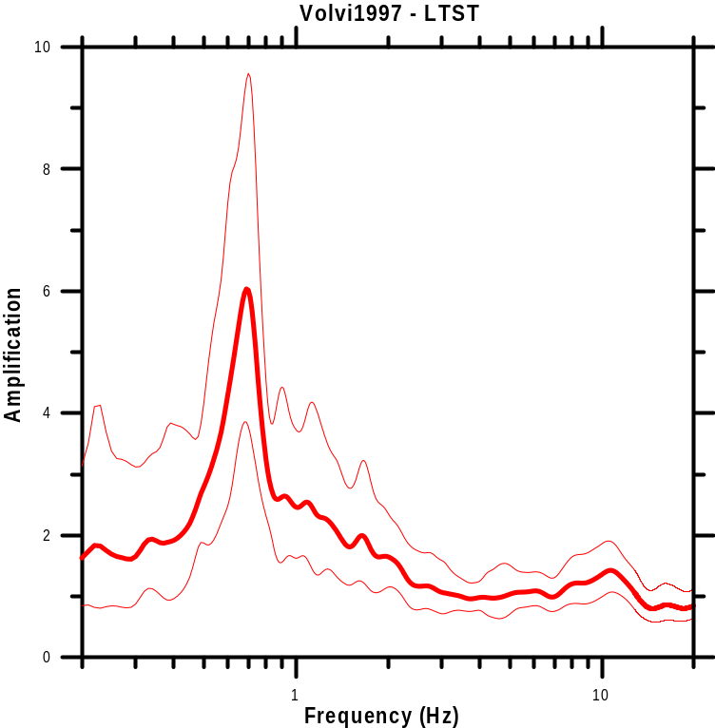
F₀

Basin geometry: Elongated alluvial valley, width~5km, length~40km, Depth~200m

Site Information
LTST site depth to bedrock: 196m
Type of bedrock: Gneiss
Average shear wave velocity of deposits: 570m/s

Comments
Criteria for a reliable H/V curve are fulfilled, that is:
f₀ > 10 / l_{w}
n_{c} (f₀) > 200
σ_{A}(f) < log₁₀(2)

Criteria for an ideal H/V peak are also fulfilled:
A₀ (=6) > 2
∃ f⁻ ∈ [f₀/4, f₀] | A_{H/V}(f⁻) < A₀/2
∃ f⁺ ∈ [f₀, 4f₀] | A_{H/V}(f⁺) < A₀/2
σ_{f} (=14%) < ε (f₀) (=15%)
σ_{A}(f₀) (=1.6) < θ (f₀) (=2)

Interpretation : All criteria are fulfilled, the fundamental frequency of the site may be reliably estimated at 0.7 Hz.
2. Unclear Low Frequency Peak

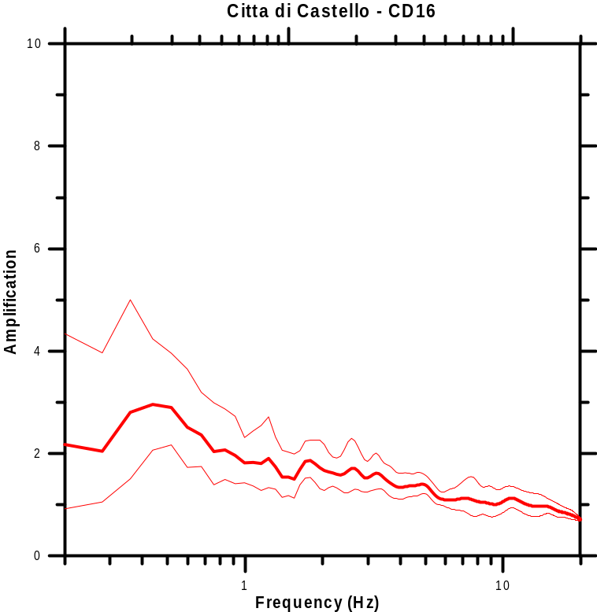
F₀

Basin geometry: Elliptical alluvium valley, width~10km, length~25km, depth~0.1km

Site Information
CD16 site is situated on soft alluvium sediments and silty clay.
Type of bedrock: Sandstone (Middle Miocene).

Comments
Criteria for a reliable H/V curve are fulfilled, that is:
f₀ > 10 / l_{w}
n_{c} (f₀) > 200
σ_{A}(f) < log₁₀(2)

In addition:
Although A₀(=2.9) > 2, the peak cannot be qualified "clear" since the amplitude is not decreasing rapidly on each side.
None f₁ ∈ [f₀/4, f₀] | A_{H/V}(f₁) < A₀/2
None f₂ ∈ [f₀, 4f₀] | A_{H/V}(f₂) < A₀/2

Interpretation : further tests should be performed as listed in section II-3.3.2-b
3. Two Peaks Cases (f₁>f₀)

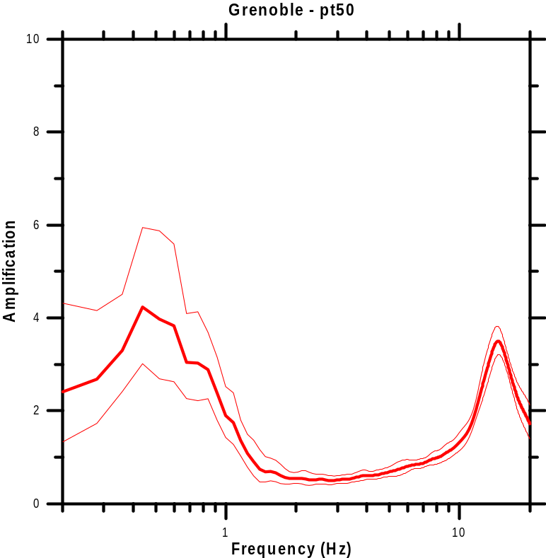
F₀
F₁
F₁

Basin geometry: Y-shaped sedimentary valley, Depth~800m

Site Information
PT50 site is situated on late quaternary post-glacial deposits.
Type of bedrock: Jurassic marls and marly limestone.

Comments
Criteria for a reliable H/V curve are fulfilled, that is:
f₀ > 10 / l_{w}
n_{c} (f₀) > 200
σ_{A}(f) < log₁₀(2)

Interpretation :
For the low frequency peak, A₀(=4.0) > 2 and ∃ f₂ ∈ [f₀, 4f₀] | A_{H/V}(f₂) < A₀/2
Although, strictly speaking, one cannot find f₁ ∈ [f₀/4, f₀] | A_{H/V}(f₁) < A₀/2, the general trend of the curve, together with the known geology of the site, allow the meaning of the low frequency peak to be assigned with confidence; another processing with more narrow band smoothing would satisfy the criteria

For the second peak, all the criteria are fulfilled:
A₁(=3.5)>2
∃ f₁ ∈ [f₁/4, f₁] | A_{H/V}(f₁) < A₁/2
∃ f₂ ∈ [f₁, 4f₁] | A_{H/V}(f₂) < A₁/2
This second peak around 13 Hz is certainly associated with a very shallow structure.
4. Broad Peak or Multiple Peaks

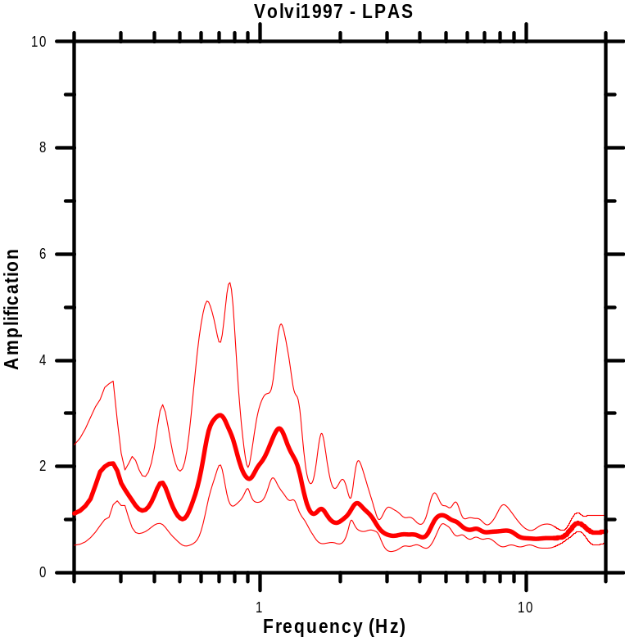
F₁
F₂
F₃

Basin geometry: Elongated alluvial valley, width~5km, length~40km, Depth~200m

Site Information
LTST site depth to bedrock: ~180m
Type of bedrock: Gneiss
Average shear wave velocity of deposits: 570m/s

Comments
Criteria for a reliable H/V curve are fulfilled, that is:
f₀ > 10 / l_{w}
n_{c} (f₀) > 200
σ_{A}(f) < log₁₀(2)

Interpretation : All three peaks fulfil the criterion for amplitude, A_{i}>2. However, only the peaks F₂ and F₃ fulfil all “clarity” criteria (3.3.1). The availability of other information (geology, deposit thickness, geophysics) in that area allows us to identify f₂ as the fundamental frequency of the site. The location of this site close to a valley edge may explain the presence of these two peaks with rather low amplitude, while another nearby site (LTST, see above the "clear peak" example") exhibits a clear peak with larger amplitude: the latter is located in the central, part of the graben.

5. Sharp Peaks and Industrial Origin

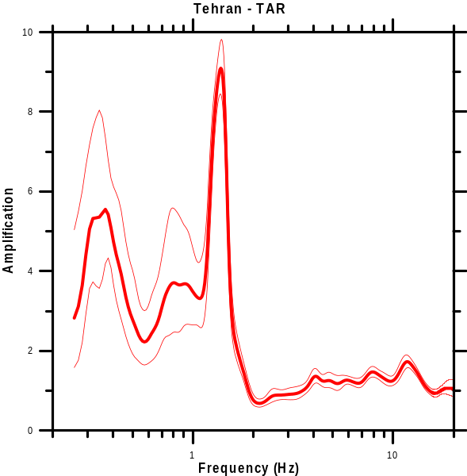
F₀
F₁
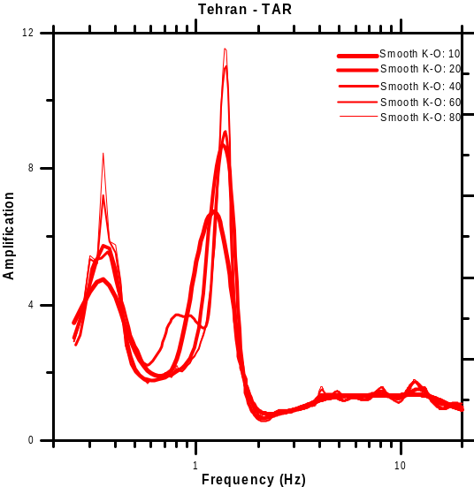
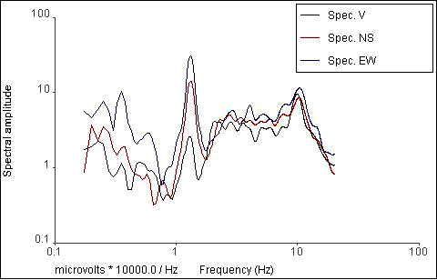

Basin geometry: Unknown

Site Information
TAR site is overlain with stiff soil (coarse grained alluvium).

Comments
Criteria for a reliable H/V curve are fulfilled, that is:
f₀ >10 / l_{w}
n_{c} (f₀) > 200
σ_{A}(f) < log₁₀(2)

The F₁ local narrow peak has an industrial origin. This (H/V) spectral ratio peak is due to manmade noise/machinery; the reprocessing with different smoothing parameters (bottom right) shows it becomes narrower and narrower, with a larger and larger amplitude when the b-value (Konno-Ohmachi smoothing approach) is increasing: this behaviour is typical of industrial origin. Another confirmation is obtained form the fact this narrow peak occurs at the same frequency in the Fourier spectra of all three components (Figure on bottom left).
6a. Flat H/V Ratio Curves [on sediments]

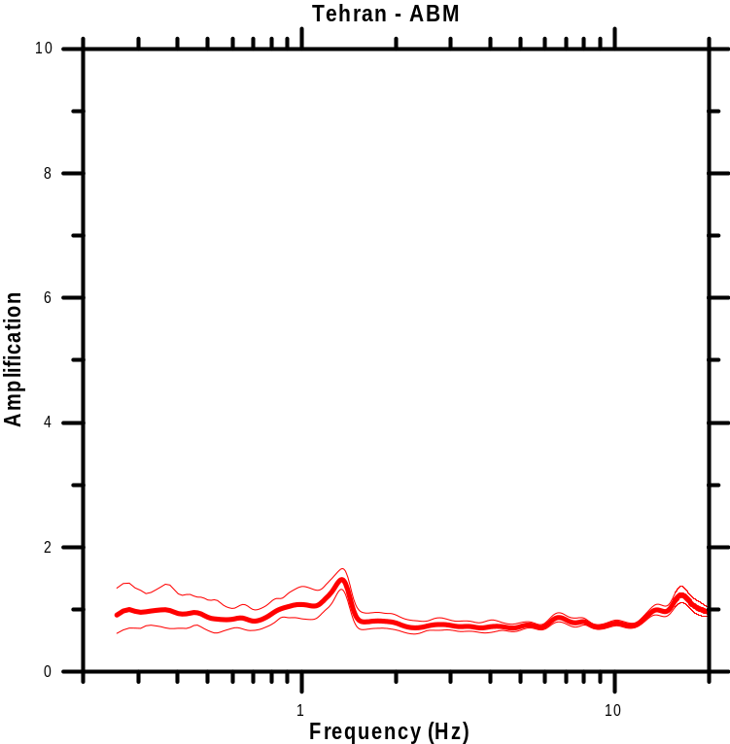

Basin geometry: Unknown

Site Information
ABM site is characterised by stiff soil (coarse grained alluvium) overlying bedrock at an unknown depth.

Comments
Criteria for a reliable H/V curve are fulfilled, that is:
f₀ >10 / l_{w}
n_{c} (f₀) > 200
σ_{A}(f) < log₁₀(2)

Significant low frequency amplification (F<1.0 Hz) was found for the ABM sedimentary site using earthquake data, which does not appear in the H/V ratio. This site is one of the few examples of non-rock sites exhibiting a flat H/V curve though also exhibiting a significant low frequency amplification (less that 5% of the total number of sites studied, as can be seen on Figure 8, section 3.1)

Note: the peak around 1.3 Hz was shown to have an industrial origin.
6b. Flat H/V Ratio Curves [on rock]

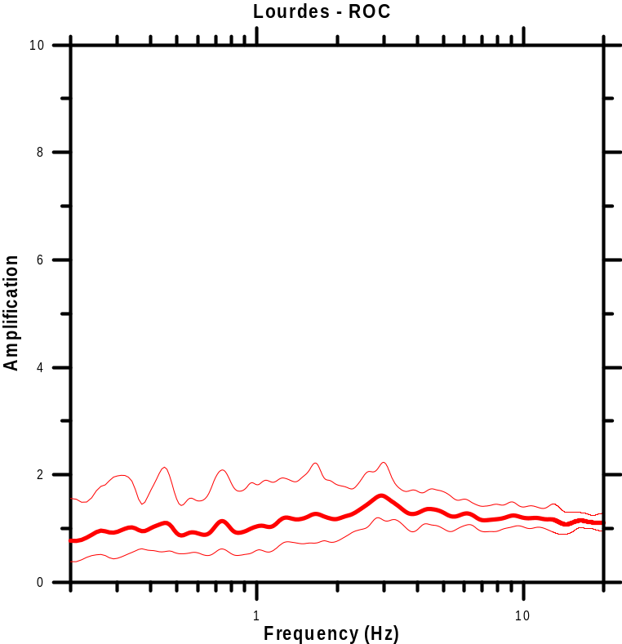

Basin geometry: Confluence of two valleys

Site Information
ROC site is situated on rock outcrop at the confluence of two valleys (reference site). (Dubos et al., 2003; Dubos, 2003)

Comments
Criteria for a reliable H/V curve are fulfilled, that is:
f₀ >10 / l_{w}
n_{c} (f₀) > 200
σ_{A}(f) < log₁₀(2)

The H/V ratio is flat over the whole frequency range examined. As the available geological information unambiguously indicates that it is a hard rock site, this flat H/V curve may be interpreted as indicative of a good, non weathered reference site free of any amplification even at high frequencies.

A.2 Comparison with standard spectral ratios

Following the Practical User Guidelines for the implementation of the H/V ratio technique, data examples relevant to physical explanation are presented. Along with each figure some explanation/comments with respect to the site information and its fundamental frequency are given. Figures below represent the ambient vibration average H/V ratio (thick red line) multiplied / divided by 10^{σ(logH/V)} (thin red line) and the earthquake recordings average standard spectral ratio [SSR] (thick black line) multiplied / divided by 10^{σ(logSSR)} (thin black line).

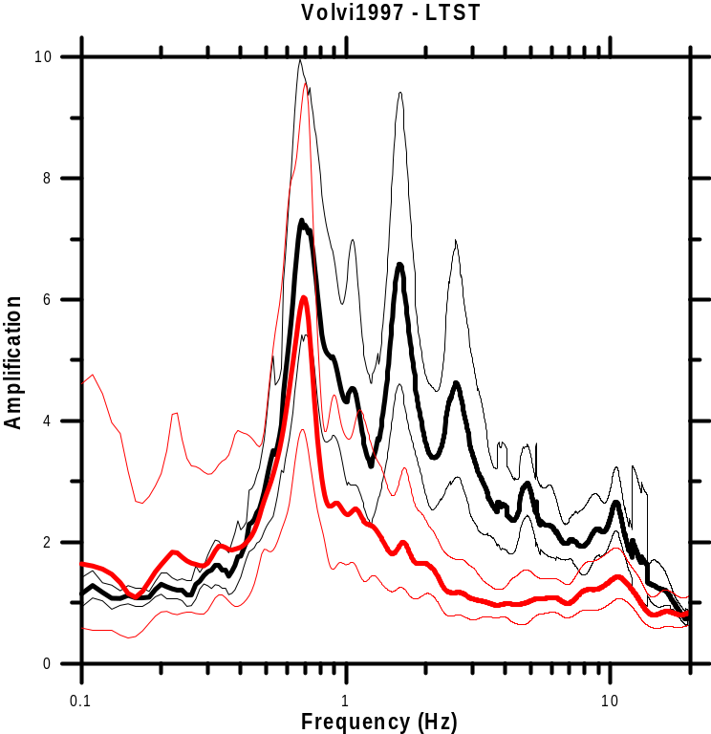

Site: LTST (Mygdonian Basin, Northern Greece)
Surface Geology: Soft
Basin Geometry: Semi-elliptical 3D basin
Surface Topography: Flat
Site Description: Agricultural area

Comments: A clear and unique (H/V) spectral ratio peak is shown. Both approaches (SSR, H/V) exhibit the same fundamental frequency (f_{o}=0.7Hz). The LTST site is very well documented with geotechnical/geophysical data and the 2D theoretical transfer function is in good agreement with the experimental one.

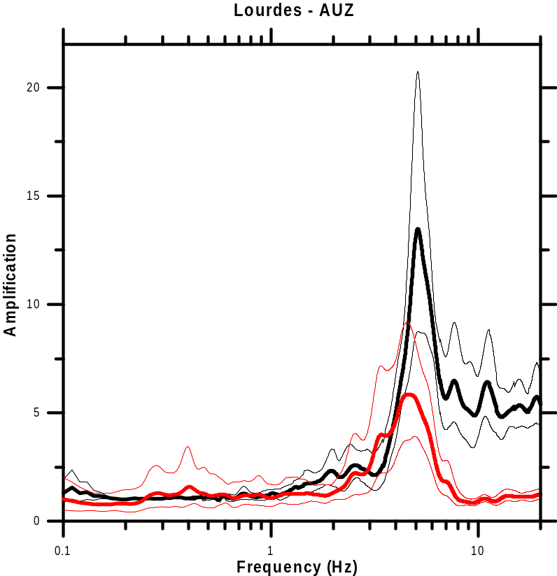

Site: Auzon-Lourdes (France)
Surface Geology: Stiff and shallow sediments (Dubos et al, 2003; Dubos, 2003)
Basin Geometry: 3D Basin
Surface Topography: Flat
Site Description: Urban

Comments: A clear and unique (H/V) spectral ratio peak is shown. Both approaches (SSR, H/V) exhibit almost the same fundamental frequency (f_{o}=5.0 Hz).

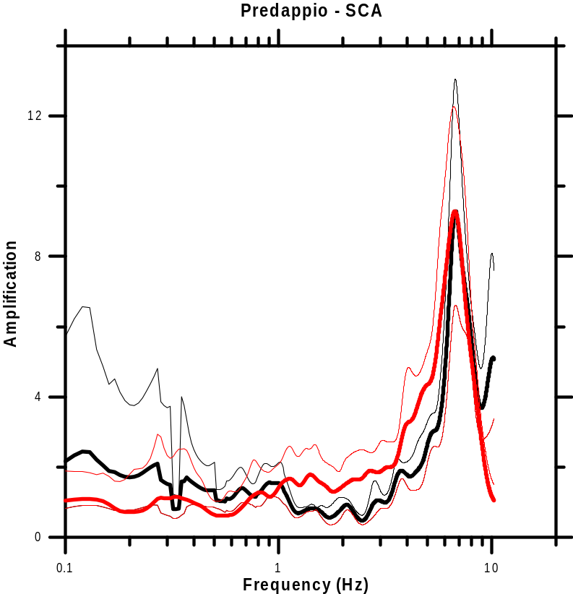

Site: Predappio (Italy)
Surface Geology: Soft (8m overlying rock)
Basin Geometry: Cylindrical
Surface Topography: Flat
Site Description: Urban

Comments: A clear and unique (H/V) spectral ratio peak is shown in high frequencies. Both approaches (SSR, H/V) exhibit the same fundamental frequency (f_{o}=7.0 Hz).

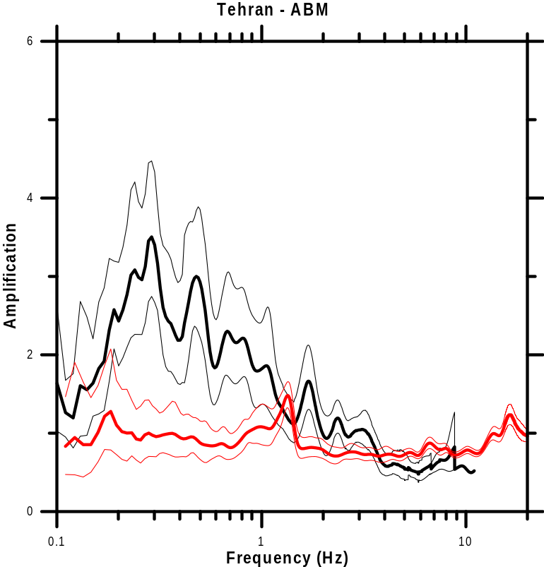

Site: Tehran (Iran)
Surface Geology: Stiff ABM site is characterised by stiff soil (coarse grain alluvium) overlying bedrock at an unknown depth.
Basin Geometry: Unknown
Surface Topography: Flat
Site Description: Urban

Comments: No clear (H/V) spectral ratio peak appears in the low frequency band (f<1.0Hz), although it is clear in the SSR technique. To the contrary, a sharp peak with an amplitude of about 1.5 appears at about 1.3Hz. This (H/V) spectral ratio peak is due to manmade noise/machinery since it appears in the Fourier spectra of all three components.

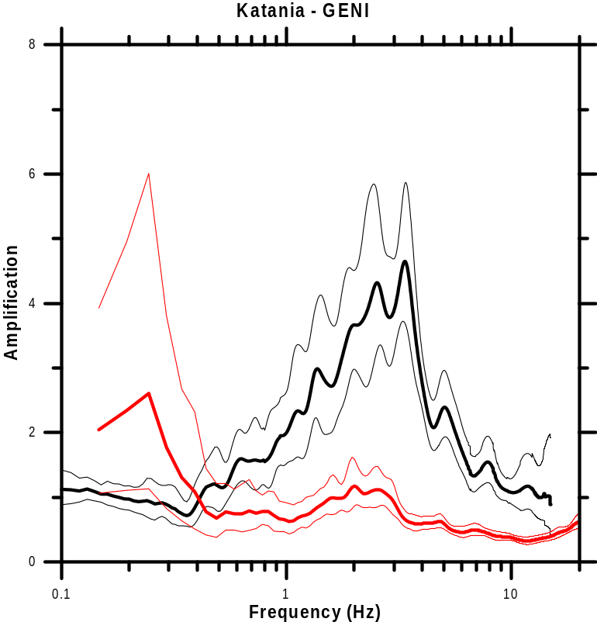

Site: Catania (Italy)
Surface Geology: Soft
Basin Geometry: Unknown
Surface Topography: Flat
Site Description: Urban

Comments: No clear (H/V) spectral ratio peak appears in the frequency band [1.0 Hz, 4.0 Hz], although it is clear in the standard spectral ratio technique. The low frequency peak (0.25 Hz) in the H/V curve is not reliable since the associated standard deviation is large, and the amplitude does not decrease enough at lower frequencies.

APPENDIX B: Physical explanations

The interpretation of the H/V spectral ratio is intimately related to the composition of the seismic wave-field responsible for the ambient vibrations, which in turn is dependent both on the sources of these vibrations, and on the underground structure. It is also related to the effects of the different kinds of seismic waves on the H/V ratio. The present section will briefly summarise, for each of these issues, the status of knowledge and consensus reached by the SESAME participants at the end of three years of intensive work and exchanges, also benefiting from an abundant scientific literature (see Bonnefoy-Claudet et al., 2004, SESAME deliverable D13.08, for a comprehensive review). It will conclude with a presentation of our resulting "preferred" interpretations of the H/V peak, which form the basis of the interpretation guidelines presented in section 3 of Part II.

One must however admit that our knowledge is still very incomplete and partial: we by no means claim everything is known and clear, and much remains to be learnt! The reader is thus strongly invited to consider this section simply as a snapshot of the views of the SESAME participants, which, though based on three years of in-depth investigations, will certainly evolve throughout the next decade.

B.1 Nature of ambient vibration wavefield
Understanding the physical nature and composition of the ambient seismic noise wavefield, especially in urban areas, requires answering two sets of questions, which are not independent of each other:
- What is the origin of the ambient vibrations (where and what are the sources)?
- What is the nature of the corresponding waves, i.e., body or surface waves? What is the ratio of body and surface waves in the seismic noise wavefield? Within surface waves, what is the ratio of Rayleigh and Love waves? Again within surface waves, what is the ratio of fundamental mode and higher modes?

While there is a relative consensus on the first question, only few and partial answers were proposed for the second set of questions, for which a lot of experimental and theoretical work still lies ahead.

As known and taught for a long time in Japan, sources of ambient vibrations are usually separated in two main categories: natural and human, which very often – and more particularly within urban areas - correspond to different frequency bands:
- At low frequencies (f < f_{nh} ≈ 1Hz), the origin is essentially natural, with a particular emphasis on ocean waves, which emit their maximal energy around 0.2 Hz. These waves can be very easily seen on islands and/or during oceanic storms. Higher frequencies (around 0.5 Hz) are emitted along coastal areas due to the interaction between sea waves and coasts. Some lower frequency waves (f << 0.1 Hz) are also associated with atmospheric forcing, but this frequency range has very little interest for engineering seismology. Higher frequencies (> 1 Hz) may also be associated with wind and water flows.
- At high frequencies (f > f_{nh} ≈ 1Hz), the origin is predominantly related to human activity (traffic, machinery); the sources are mostly located at the surface of the earth (except some sources like metros), and often exhibit a strong day/night and week / weekend variability.

The 1 Hz limit for f_{nh} is only indicative, and may vary from one city to another. Some specific civil engineering works (highways, dams) involving very big engines and/or trucks may also generate low frequency energy. Locally, this limit may be found by analysing the variations of seismic noise amplitude between day and night, and between work and rest days as well.

Energetic low frequency sources are often distant (being located at the closest oceans), and the energy is carried from the source to the site by surface waves guided in the earth's crust. However, locally, these waves may (and actually often do) interact with the local structure (especially deep basins). Their long wavelength induces a significant penetration depth, so that the resulting local wavefield may be more complex: subsurface inhomogeneities, excited by the long period crustal surface waves, may act as diffraction points and generate local surface waves, and even possibly body waves. The energy at frequencies between 0.1 and 1.0 Hz decreases with increasing distance from oceans: extracting information from microseisms is thus easier on islands (such as Japan) than in the heart of continental areas (such as Kazakhstan).

High frequency waves generally correspond to much closer sources, which, most of the time, are located very close to the surface: while the wavefield in the immediate vicinity (less than a few hundred meters) includes both body and surface waves, at longer distances, surface waves become predominant.

Besides this very qualitative information, only very little information is available on the quantitative proportions between body and surface waves, and within the different kinds of surface waves that may exist (Rayleigh / Love, fundamental / higher). The few available results, reviewed in Bonnefoy-Claudet et al. (2004), report that low frequency microseisms (f < f_{nh}) predominantly consist of fundamental mode Rayleigh waves, while there is no real consensus for higher frequencies (> 1 Hz). Different approaches were followed to reach these results, including analysis of seismic noise amplitude at depth and array analysis to measure the phase velocity.

The very few investigations on the relative proportion of Rayleigh and Love waves all agree on more or less comparable amplitudes, with a slight trend towards a slightly higher energy carried by Love waves (around 60% - 40%). In addition, there are a few reports about the presence of higher surface wave modes from several very different sites (some very shallow, other much thicker, some other with low velocity zone at depth).

The following Table summarises (with some simplification however) the above discussion.

 | Natural | Human
Name | Microseism | Microtremor
Frequency | 0.1 – f_{nh} (0.5 Hz to 1 Hz) | f_{nh} (0.5 Hz to 1 Hz) – > 10 Hz
Origin | Ocean | Traffic / Industry / Human activity
Incident wavefield | Surface waves | Surface + body
Amplitude variability | Related to oceanic storms | Day/ Night, Week / week-end
Rayleigh / Love issue | Incident wavefield predominantly Rayleigh | Comparable amplitude – slight indication that Love waves carry a little more energy
Fundamental / Higher mode issue | Mainly Fundamental | Possibility of higher modes at high frequencies (at least for 2-layer case)
Further Comments | Local wavefield may be different from incident wavefield | Some monochromatic waves related to machines and engines. The proximity of sources, as well as the short wavelength, probably limits the quantitative importance of waves generated by diffraction at depth

These results, although partial, do indicate that the seismic noise wavefield is indeed complex, especially at "high" frequencies where the origin is human activity: when interpreting the H/V ratio, one has therefore to consider the possible contributions to H/V from both surface and body waves, including also higher modes of surface waves.

B.2 Links between wave type and H/V ratio
The wavefield being a mixture of Love, Rayleigh and body waves, the origin of the H/V peaks (and troughs) is multiple: Rayleigh wave ellipticity, Airy phase of Love wave modes, resonance of S and/or P body waves. This section begins with a brief outline of the effect of each individual wave type on the H/V ratio, on the basis of simple wave propagation physics. The issue of more complex wavefields is then addressed with a summary presentation of the main learnings obtained from numerical simulation in complex media.

B.2.1 H/V and surface waves
B.2.1.1 H/V and Rayleigh waves
Rayleigh waves are characterised by an elliptical particle motion in the radial plane, and their phase velocity. In horizontally stratified media where velocity varies with depth, both characteristics exhibit frequency dependence. Stratification also gives rise to the existence of distinct Rayleigh wave modes: while the fundamental mode exists at all frequencies, higher modes appear only beyond some cut-off frequencies, the values of which increases with the mode order. The H/V ratio of all modes of Rayleigh waves, which is a measure of the ellipticity ratio, exhibits therefore a frequency dependence in stratified media.

There exist a rich literature on that topic, a list of which may be found in Kudo (1995), Bard (1998), Stephenson (2003), Malischewsky and Scherbaum (2004) and Bonnefoy-Claudet (2004). The main relevant results may be summarised as follows, considering first simple one layer over half-space structures:
- For intermediate to high S-wave velocity contrasts (i.e., larger than about 3), the H/V ellipticity ratios of Rayleigh waves exhibit infinite peaks and/or zeros corresponding to the vanishing of the vertical (respectively horizontal) component, and inversion of rotation sense (from retrograde to prograde, or inversely). For low impedance contrasts, because the rotation sense does not change with frequency, the ellipticity ratio only exhibits maxima at some frequencies and minima at other frequencies with no zeroes or infinities.
- Focusing first on the fundamental mode, the vanishing of the vertical component occurs at a frequency f_{R} which is very close (i.e., less than 5% different) to the fundamental resonance frequency for S waves only if the S-wave velocity contrast exceeds a value of 4. For intermediate velocity contrasts (2.6 to 4), the ellipticity peak is still infinite and occurs at a frequency that may be up to 50% higher than the S-wave fundamental resonance frequency. For lower velocity contrasts, the infinite peak is replaced by a broad maximum that has only low amplitude (less than 2-3), and occurs at a frequency that may range between 0.5 to 1.5 times the S-wave fundamental frequency.
- The ellipticity ratio H/V of the fundamental mode may also exhibit not only a peak at f_{R}, but also a minimum (zero) at a higher frequency f_{z}, corresponding to the vanishing of the H component, and a second rotation sense inversion (from prograde to retrograde). A few studies have been performed to investigate the variability of the ratio f_{z}/f_{R}; while Konno and Ohmachi (1998) report a value around 2 for a limited set of velocity profiles, Stephenson (2003) concludes that peak/trough structures with a frequency ratio around 2 witness both a high Poisson ratio in the surface soil, and a high impedance contrast to the substrate. Some other studies for more complex velocity profiles report a dependence of the ratio on the velocity gradient in the soft sediments.
- Higher modes exhibit also H/V peaks at higher frequencies corresponding to a vanishing V component; some of these peaks, especially for high contrast structures, coincide with the higher harmonics of S-wave resonance. However, for single layer structures, no case is known, for which all existing Rayleigh wave modes exhibit simultaneously a peak at the same frequency. In other words, for all frequencies for which several modes exist simultaneously (i.e., generally beyond the S-wave fundamental frequency), there always exist one Rayleigh wave mode (often the fundamental one) which may carry some energy on the vertical component.
- These results may generally be extrapolated to more complex horizontally layered structures involving several layers or velocity gradients; one major difference however concerns item iv) and the number of ellipticity peaks. Some sites may present a large velocity contrast (i.e., exceeding at least 2.5) at different depths z_{k} (however, given the minimum threshold of 2.5, the number of such depths rarely exceeds 2…). In such cases, the S-wave response will exhibit major amplifications at frequencies f_{k} corresponding to the fundamental frequencies of the layering located above these depths with major discontinuity. In such cases, the available results show that all Rayleigh wave modes existing at frequency f_{k} do exhibit a common ellipticity peak (in other words, the vertical component of all existing Rayleigh wave modes vanish at frequencies f_{k}). In such sites, a H/V curve with several sites is therefore consistent with the surface wave interpretation. An example of this situation is a shallow very soft layer resting on a thick, stiff unit underlain by very hard bedrock.
- No relation could be established between the S-wave amplification at the resonance frequency, and the characteristics of the H/V infinite peak (for instance its width) or maximum amplitude.

B.2.1.2 H/V and Love waves
Love waves carry energy only on the horizontal component. Their influence on the frequency dependence of the H/V ratio can therefore come only from the frequency dependence of the H component.

Different studies (see for instance Konno & Ohmachi, 1998) have shown that, at least for high impedance contrast cases, Love waves do strengthen the H/V peak: all surface waves carry their maximum energy for frequencies corresponding to group velocity minima ("Airy phase"); for high impedance contrast layering, the group velocity minimum of the fundamental Love mode occurs, like for the vanishing of V component, at a frequency f_{L} which is very close to the fundamental S-wave frequency.

Higher modes of Love waves may also have group velocity minima and associated Airy phases at higher frequencies: this may result in other maxima if higher modes carry a significant amount of energy.

B.2.2 H/V and body waves
As site amplifications occurring during actual earthquakes essentially involve incoming body waves, it is obvious that the horizontal and vertical components of body waves are both highly sensitive to site conditions. The main question to address here is the relation of the H/V ratio and site conditions for body waves; a side question concerns the differences or similarities between H/V ratios derived from earthquake recordings and H/V ratios derived from ambient vibration recordings.

When considering, once again, a simple horizontally layered structure with one soft layer over a half-space, and its response to obliquely incident plane waves, a striking result is the fact that, whatever the incident wave type (P or SV or SH), the horizontal components systematically exhibit resonant peaks at the S-wave resonance frequencies (even for P wave incidence), while the vertical component always exhibit resonant peaks at the P-wave resonance frequencies (even for S wave incidence). This result is valid when the impedance contrast is large both for S and P waves, and comes from the conversion from P and SV waves at the bedrock/layer interface, and their relatively small incidence angles within the surface lower velocity layer.

This has very interesting consequences for the fundamental mode, since the S-wave fundamental frequency is always significantly smaller than the P-wave fundamental frequency (ratio equal to the S-P velocity ratio within the surface layer):
- As the fundamental frequency is only weakly dependent on subsurface topography – for usual configurations –, this explains why the H/V ratio for a body wavefield should always exhibit a peak around the fundamental S-wave frequency, for high impedance contrast sites.
- In the case of horizontally stratified media, the H/V ratio should also exhibit peaks at the S-wave harmonics, at least for all peaks that do not coincide with a lower order harmonic of P-wave resonance.
- Finally, again for high impedance contrast, horizontally stratified media, the amplitude of the first H/V peak is also expected to be somewhat correlated with the S wave amplification.

These latter two items constitute the main differences from the surface wave case, where it is not generally expected to have either harmonics, or any correlation between H/V peak amplitude and actual amplification values. The presence or absence of harmonics at least for a large impedance contrast, 1D structure, may thus be a good indicator of the composition of the wavefield.

One should remain very cautious however in interpreting H/V ratios derived from earthquake recordings beyond the fundamental S frequency, since this ratio is highly influenced by the amplification of the vertical component, which cannot be neglected, especially in sites with pronounced subsurface topography.

B.2.3 H/V and complex wavefields: results from numerical simulation
Since the actual composition of the seismic noise wavefield is mostly unknown, a series of numerical simulations have been performed to investigate the origin of an H/V peak. A wide variety of subsurface structures have been studied (1D, 2D and 3D), but only "local" sources have been considered (i.e., less than about 10 km away from the receiver): the "microseism" case has not yet been investigated (incoming crustal surface waves generated by oceanic waves). These comprehensive analyses are presented and discussed in various reports (SESAME deliverables D12.09 and D17.10, Bonnefoy-Claudet, 2004), and only the main conclusions are summarised below:
- for 1D structures, a single H/V peak is obtained only when the predominant noise sources are located within the surface layer and within limited distances from the site (less than around 20 -30 times the layer thickness); the wavefield then consists of a mixture of Rayleigh, Love and body waves. For more distant dominant noise sources (a case not often met in urban sites, but possible in the countryside), and/or deep sources (i.e., located at depth below the interface associated with the main impedance contrast), the wavefield includes a large proportion of body or head waves, especially at high frequencies, and H/V curves exhibit several peaks associated with fundamental and harmonics of S-wave resonance. In all cases, the frequency of the fundamental peak exhibits a very good agreement (within ± 20% at most) with the actual fundamental S-wave frequency of the layered structure.
- For laterally varying structures, the wavefield associated with "local" noise sources is more complex, since it also includes additional waves diffracted from the lateral heterogeneities. The composition of this diffracted wavefield depends on the location of the site of interest with respect to the lateral heterogeneities: away from them (for instance, in the flat central parts of valleys and basins), it mainly consists of surface waves (fundamental or higher mode depending on the frequency); close to them it also includes a significant portion of body waves. For all the investigated simulation cases (all with a large impedance contrast), H/V curves exhibit clear (sharp) peaks in the "flat" parts (i.e., those with only gentle underground interface slopes), and broader and generally lower maxima at sites with rapidly varying thickness (for instance at valley edges). The frequency of the sharp peaks ("flat" parts) agrees within ± 20% with the resonance frequency of the structure (possibly different from the 1D value for deeply embanked valleys), while the bandwidth of the broad peaks (sites with steep underground interfaces) is generally indicative of the fundamental frequency variations between the shallowest and deepest sections; however, the amplitude of this broad maximum is often too small to allow a clear identification, at least in the absence of any additional geological information and/or dense geographic coverage of ambient vibration measurement points.

Additional comment : H/V and surface topography
All the above discussion and results implicitly addressed mainly sedimentary / alluvial sites within valleys or plains, and are therefore valid only for horizontal free surfaces. As frequency dependent site amplification has been repeatedly observed also on top of rocky hills, several attempts have been performed to investigate whether H/V ratios from ambient vibrations also exhibit a peak in the same frequency range. These attempts have generally been successful, but no theoretical interpretation and no numerical simulation have been proposed to explain this apparent success.

The surface topography issue was not addressed within the SESAME project, and we will therefore only indicate here that surface waves are certainly affected by non flat free surfaces, resulting in a diffracted wavefield (as for non horizontal underground layering) including both surface and body waves. Even when considering surface weathering, the impedance contrast between surface and depth usually remains limited; there is therefore only a small probability that the H/V peak comes from a vanishing of the V component, and we consider more likely an explanation in terms of body waves, involving both diffraction and focusing. This is however only a suggestion, and the topic would deserve thorough further investigations, especially as the "surface topography" amplification effect itself is far from being properly understood.

B.3 Consequences for the interpretation of H/V curves
The above mentioned results exhibit a few consistent, robust characteristics which have to be kept in mind when interpreting H/V curves and peak(s):
- The results are clear and simple in case of horizontally layered structures with large impedance contrasts (> 4-5).
- The results become more and more fuzzy a) for decreasing contrasts and b) for increasing underground interface slopes.
- Theoretical and numerical results are by far more numerous and easier to interpret for local, anthropic like sources, i.e., essentially, above 1 Hz.
- Clear urban situations with non stationary, spatially distributed local sources are generally associated with one single H/V peak.
- In the Rayleigh wave interpretation, the H/V peak should be associated with a (local) trough in the Fourier spectra of the vertical component, while Love or body wave interpretations should be associated with a (local) peak in the Fourier spectra of the horizontal component

This has the following direct practical consequences for H/V investigations:
- One should always gather the available geological and geotechnical information, looking in particular for a priori rough estimations of impedance contrasts (keeping in mind that large impedance contrasts are generally associated with either very young unconsolidated deposits, or very hard bedrock), and indications as to the lateral variability of underground structures.
- Low-frequency peaks (i.e., < 1 Hz) are often less easy a) to detect and b) to interpret than high-frequency peaks. Additional measurements in the vicinity of the site of interest often help to find a consistent H/V peak.
- One should never forget to have a look at the original Fourier spectra of the horizontal and vertical components, especially when the H/V maximum is not very clear.

One must also bear in mind that real ambient vibration recordings also include a number of "spurious" sources (such as wind, or industrial harmonic machinery) which may affect the estimation of the H/V curve, and downgrade the possibility of interpretations: while clear and sharp "natural" peaks generally remain visible, fuzzy maxima may completely disappear.

B.3.1 1D media
When the available geological information allows the deposit to be considered as horizontally layered with a smooth and flat interface with the underlying bedrock, at least locally, then the wavefield composition and interpretation of H/V ratio can be seen as follows:

B.3.1.1 High frequencies (human origin, f > f_{nh} , f_{nh} ≈ 1 Hz)
- If the site is located in an urban environment, the "noise" sources are essentially local and superficial; the wavefield predominantly consists of surface waves (Rayleigh and Love) with however a slight proportion of body waves. The H/V curve should exhibit one single peak, at a frequency that is within ± 20% of the S-wave resonant frequency of the site. The amplitude of that peak should not be interpreted in terms of amplification values.
- If the site is located in the countryside and the predominant sources are distant, the wavefield also includes resonating head waves and the H/V curve may exhibit several peaks corresponding to the various harmonics

B.3.1.2 Low frequencies (oceanic origin, f < f_{nh} , f_{nh} ≈ 1 Hz)
Unless there exist energetic low frequency sources (big trucks or engines) close to the site under consideration, the seismic noise wavefield is most probably caused by oceanic activity. This may be checked through continuous measurements and an analysis of the daily / weekly amplitude variations.

The local geological structure certainly does not exist over the whole distance between the site and the ocean: therefore the low frequency crustal surface waves carrying the noise energy certainly undergo some conversion (mode conversion : Rayleigh / Love, fundamental / higher) and/or type conversion (surface to body waves) along laterally varying substructures at some distance from the site. For instance, for a deep inland basin, incoming low frequency crustal waves have a penetration depth of at least 1 km, and will be diffracted along basin edges: in such a case, the sources of seismic noise may be seen as a collection of point sources located along the basin / bedrock interface, re-emitting the same energy envelope spectrum as different waves: local surface waves and body waves. The associated H/V ratio should then be somewhat similar to the H/V ratio derived from earthquake recordings, in the low frequency range only of course (if available, site to reference rock spectral ratios should then be also comparable for ambient vibration and earthquake recordings).

Low frequency H/V peaks are associated either with extremely soft soil (e.g., Mexico City clays) with a thickness of several tens of meters, or with "normal" soil deposits having a very large thickness (several hundred meters at least): the former case is obviously associated with a large impedance contrast, while this can occur in the latter case only if the bedrock is very hard (the confining pressure at large depth automatically induces a stiffness increase).

B.3.2 2D / 3D structures
We consider here sites under which at least one of the interfaces with significant impedance contrast exhibits steep slopes (i.e., larger than around 10°, this value being however only indicative). Such sites are therefore either "transition" zones between areas with more or less horizontal layering, or deeply embanked valleys and basins having a large thickness to width ratio (typically, larger than 0.2).

B.3.2.1 Transition zones
If such transition zones are expected from the available geological / geotechnical / geophysical information, it is always recommended that measurements be made on each part of the transition zone, and to have a rather dense measurement mesh (the "density" being related to the predominant wavelength, i.e., to the frequency: the higher the frequency the smaller the mesh size.

High frequencies (human origin, f > f_{nh} , f_{nh} ≈ 1 Hz, possibly varying from site to site)
Numerical simulations have consistently shown that, for local surface sources, the H/V curve at such "transition" sites exhibit broader and lower maxima, which may be hard to identify: surface waves cannot develop with one single "pure" mode, nor can resonance of body waves occur.

Low frequencies (oceanic origin, f < f_{nh} , f_{nh} ≈ 1 Hz, possibly varying from site to site)
No simulation is available for incoming crustal surface waves; the local diffraction phenomena already mentioned for this case let us think that the wavefield should include a significant proportion of body waves generated at depth, so that the H/V ratio should reflect at least partly the differential amplification between H and V components, and be a more reliable indicator of the site frequency than for high frequency local surface sources. This interpretation is not consensual and should be taken with caution.

B.3.2.2 Deeply embanked valleys and basins
The presence of such deep structures should be at least guessed from the geological map and a minimum knowledge of the geological history of the area (ancient glacier valleys filled with lacustrine deposits are a typical example of such structures). However, this kind of structure may also be met in the case of buried canyons, which may remain unknown in the absence of detailed geophysical surveys.

When associated with large impedance contrasts, the seismic response of these structures to incoming body waves exhibits a global 2D (or 3D) resonance pattern characterised by similar resonance frequencies at all sites, whatever the local thickness, and mode shapes with both a strong spatial dependence, and a strong polarisation. As a consequence, a) resonance frequencies may be different on the two horizontal components (for instance, in a valley, the components parallel - // - and perpendicular - ⊥ - to the valley axis), and b) the amplitude of the corresponding H/V peak may undergo significant variations from site to site, due to variations in both H and V components (for instance, a given mode may include a node in the ⊥ component at one site, and a node on the V component at another site).

Considering the importance of diffraction phenomena of steep interfaces, and the fact that these resonance modes are the eigen-solutions of the wave equation in such structures, it is logical to conclude that such modes will exist whatever the excitation wavefield, provided there is enough energy in the corresponding frequency range. This theoretical consideration is supported by the few numerical simulations performed on such structures (Cornou et al., 2004 – SESAME deliverables D12.09 and D17.10).

B.3.2.3 Common recommendations for 2D/3D structures
In any case, when other information sources (geology, geophysics, …) suggest a 2D or 3D structure, three kinds of actions / processing are strongly recommended to check these possibilities:
- One should never limit one's investigations to one single measurement, but should have a wide and dense spatial coverage, starting with a mesh size comparable with the expected thickness of the softer cover. The mesh size may be reduced in a second step in case of strong lateral discontinuities, indicating either faults or very steep underground slopes
- One should also investigate the differences between differently polarised horizontal components (i.e., applying different rotation angles) ; for instance, along valley edges, clear differences may appear between the ⊥ and // components.

